Storm Water Pollution Prevention Plan (SWPPP) Template

Project Title:
Project No.:
Department/Division: |  |  |  | /

Prepared by:
SWPPP Preparation Date:
Revision Date:

Table of Contents
1. Introduction 1
1.1. HAR Appendix C 11-55 and SWPPP Cross-Reference 1
2. Plan Administration 3
2.1. Certification of the SWPPP [7.2.17] 3
2.2. SWPPP Amendments [7.4.1-7.4.3] 3
2.3. Modifications to the SWPPP [7.4] 4
2.3.1. Required Notice to Other Contractors [7.4.5] 4
3. General Project Information [7.2.2 and 7.2.3] 5
3.1. General Project Information 5
3.2. Nature of Construction Activities [7.2.2] 5
3.3. Emergency Work [7.2.3] 5
3.4. Construction Site Estimates 6
3.5. Scope of Work 6
4. NPDES and Other State, Federal, or County Permits [7.2.15 and 7.2.18] 7
4.1. NPDES Permits 7
4.2. Drainage System Approval to Discharge 7
4.3. County Permits 8
4.4. Other Permits 8
5. Personnel and Training Records 9
5.1. Storm Water Team [7.2.1] 9
5.2. Identification of Prime Contractor and Other Site Contractors [7.2.4] 10
5.3. Staff Training [7.2.13] 11
6. Sequence and Estimated Dates of Construction Activities [7.2.5, 7.2.10.2, 5.2.1.1, and 5.2.1.2] 12
6.1. Proposed Construction Schedule [7.2.5] 12
6.2. Sequence of Activities 13
6.3. Stabilization Practices and Deadlines [7.2.10.2, 5.2.1.1, and 5.2.1.2] 14
7. Site Maps and BMP Plans [7.2.6] 15
8. Buffer Documentation [7.2.9] 17
9. Storm Water Pollutants and Control Measures [7.2.7, 7.2.8, and 7.2.10] 19
9.1. Chemicals Onsite 19
9.2. Sources of Non-Storm Water [7.2.8] 20
9.3. Best Management Practices 20
10. Spill Prevention and Response Procedures [7.2.11.1] 29
11. Waste Management Procedures [7.2.11.2] 30
12. Procedures for Inspection, Maintenance, and Corrective Action [7.2.12] 31
12.1. Personnel Responsible for Conducting Inspections 31
12.2. Required Inspections 31
12.2.1. Pre-Construction Inspection 31
12.2.2. Weekly Self-Inspections 31
12.2.3. Rainfall Event Inspections 31
12.3. Maintenance 31
12.4. Corrective Actions and Deficiencies Reporting [10.2.1 and 10.4.1] 32
12.5. Discharge Reporting [9.1.6.6] 34
12.6. Receiving Water Inspections (for individual permits only) 34
13. Post-Construction Measures [7.2.10.3] 34
14. Documentation of Compliance with Safe Drinking Water Act Underground Inject Control (UIC) Requirements for Certain Subsurface Storm Water Controls [7.2.14] 34
15. Other Information as Requested by the Director [7.2.16] 36
16. Monthly Compliance Report Submittal Requirements [13.1] 36

List of Tables
Table 1: HAR 11-55 Appendix C SWPPP Cross-Reference 1
Table 2: SWPPP Amendment Log 3
Table 3: General Project Information 5
Table 4: Required Permits 7
Table 5: Proposed Construction Schedule 12
Table 6: Site Maps and BMP Plans Reference 15
Table 7: Chemicals Used or Stored Onsite 19
Table 8: Sources of Non-Storm Water 20
Table 9: Best Management Practices to be Implemented 21
Table 10: Waste Management BMP Fact Sheets to be implemented 30
Table 11: [DRAFT] Definition of Deficiencies from the CCH Inspection and Enforcement Program for Construction Sites, 2016 33

List of Attachments
Attachment A – Contractor/ Sub-Contractor Control Maps, Property Maps, State Waters and BMP Maps, and BMP Details A-1
Attachment B1 – Training Log B-1
Attachment B2 – Sub-Contractor Certification(s) B-4
Attachment C1 – NOI, NOI Attachment, and the NGPC C-1
Attachment C2 – Other Permits/ Agreements C-2
Attachment D1 - SWPPP Inspection Form D-1
Attachment D2 – City and County of Honolulu Corrective Action Report D-6
Attachment D3 – Monthly Compliance Report D-9
Attachment D4 – CCH Critical Deficiency Report (DRAFT) D-12
Attachment D5 – Receiving Water State Inspection Report for Individual NPDES Permit Projects D-18
Attachment E – Spill Prevention and Response Procedures (SWPPP Section 7.2.11.1) E-1
Attachment F1 – Solid Waste Disclosure Forms and Receipts F-1
Attachment F2 – Litter Management Plan F-2
Attachment G – Contingency Plan G-1
Attachment H – Post-Construction Storm Water Quality Report H-1
Attachment I - Emergency Related Projects, Buffer Documentation, Documentation of Compliance with UIC Requirements, & Other Information as Requested by the Director I-1

Introduction

This Storm Water Pollution Prevention Plan (SWPPP) has been prepared to meet the requirements of:
- Hawaii Administrative Rules (HAR), Chapter 11-55, Appendix C, NPDES General Permit Authorizing Discharges of Storm Water Associated with Construction Activity
- City & County of Honolulu, Rules Relating to Water Quality
Contractors shall also reference the following documents:
- City and County of Honolulu, Storm Water Best Management Practice Manual-Construction, 2012
- [DRAFT] City and County of Honolulu, Inspection and Enforcement Program for Construction Sites, 2016
- Standard Specifications and Special Provisions
- Any other permits or conditions required for this project.
This SWPPP shall be available at the site or at an easily accessible location at all times. If an onsite location is unavailable to keep the SWPPP when no personnel are present, notice of the plan’s location must be posted near the main entrance of the construction site.

HAR Appendix C 11-55 and SWPPP Cross-Reference
This SWPPP does not follow the exact order presented in HAR 11-55 Appendix C Section 7.2 SWPPP Contents. Section headings and text identify, where appropriate, the relevant part(s) of HAR 11-55 Appendix C and a cross reference of those requirements are presented below in Table 1.
Table 1: HAR 11-55 Appendix C SWPPP Cross-Reference
HAR 11-55 Appendix C Provision | SWPPP Section | SWPPP Page Number
7.2.1 Storm Water Team | 5.1. Storm Water Team | 9
7.2.2 Nature of Construction Activities | 3. General Project Information | 5
7.2.3 Emergency Related Projects | 3.3. Emergency Work | 5
7.2.4 Identification of Other Site Contractors | 5.2. Identification of Prime and Other Site Contractors | 10
7.2.5 Sequence and Estimated Dates of Construction Activities | 6. Sequence and Estimated Dates of Construction Activities | 12
7.2.6 Site Map | 7. Site Maps and BMP Plans and Attachment A | 15, A-1
7.2.7 Construction Site Pollutants | 9. Storm Water Pollutants and Control Measures | 19
7.2.8 Sources of Non-Storm Water | 9. Storm Water Pollutants and Control Measures | 19
7.2.9 Buffer Documentation | 8. Buffer Documentation | 17
7.2.10 Description of Storm Water Control Measures | 9. Storm Water Pollutants and Control Measures | 19
7.2.10.1 Storm Water Control Measures to be used During Construction | 9.3 Best Management Practices | 20
7.2.10.2 Stabilization Practices | 6.3. Stabilization Practices | 14
7.2.10.3 Post-Construction Measures | 13. Post-Construction Measures and Attachment H | 35, H-1
7.2.11.1 Pollution Prevention and Response Procedures | 10. Spill Prevention and Response Procedures and Attachment E | 30, E-1
7.2.11.2 Waste Management Procedures | 11. Waste Management Procedures and Attachment F | 31, F-1
7.2.12 Procedures for Inspection, Maintenance, and Corrective Action. | 12. Procedures for Inspection, Maintenance, and Corrective Action and Attachment D | 32, D-1
7.2.13 Staff Training | 5.3. Staff Training and Attachment B | 10, B-1
7.2.14 Documentation of Compliance with Safe Drinking Water Act Underground Injection Control (UIC) Requirements for Certain Subsurface Storm Water Controls | 14. Documentation of Compliance with Safe Drinking Water Act Underground Injection Control (UIC) Requirements for Certain Subsurface Storm Water Controls | 35
7.2.15.1 Contractor Information | 5.2. Identification of Prime and Other Site Contractors | 10
7.2.15.2 Other State Federal, or County Permits | 4. NPDES and Other State, Federal, or County Permits and Attachment C | 7, C-1
7.2.16 Other Information As Requested by the Director | 15. Other Information as Requested by the Director | 36
7.2.17 SWPPP Certification | 2.1. Certification of the CWB SWPPP | 3
7.2.18 Post-authorization Additions to the SWPPP | 4. NPDES and Other State, Federal, or County Permits and Attachment C | 7, C-1
7.4 Required SWPPP Modifications | 2.2. SWPPP Amendments | 3

Plan Administration

Certification of the SWPPP [7.2.17]
The certifying person and duly authorized representative shall meet the requirements of Hawaii Administrative Rules 11-55, Appendix A, Section 15.

“I certify under penalty of law that this document and all attachments were prepared under my direction or supervision in accordance with a system designed to assure that qualified personnel properly gather and evaluate the information submitted. Based on my inquiry of the person or persons who manage the system, or those persons directly responsible for gathering the information, the information submitted is, to the best of my knowledge and belief, true, accurate, and complete. I am aware that there are significant penalties for submitting false information, including the possibility of fine and imprisonment for knowing violations.”

Signature |  |  |  |  |  |  |  |  |  | Date:
Person Name:
[Contractor]
Person Position Title:
Person Company or Agency:
Department: |  |  |  |  |  |  |  |  | Division:
Phone Number: |  |  |  |  |  |  |  | Fax Number:
Personal Email:

SWPPP Amendments [7.4.1-7.4.3]
Each amendment must be signed by the authorized representative authorizing the changes within seven (7) calendar days following the occurrence of any of the conditions listed below in Section 2.3. Amendments are recorded in Table 2 below.
Table 2: SWPPP Amendment Log
No. | Description of the Amendment | Date of the Amendment | Amendment Prepared by [Name(s) and Title(s)] | Certifying Signature

Modifications to the SWPPP [7.4]
Modify the SWPPP, including the site map(s), in response to any of the following conditions:
- Whenever new contractors become active in construction activities on the site, or changes are made to the construction plans, storm water control measures, pollution prevention measures, or other activities at the site that are no longer accurately reflected in the SWPPP. This includes changes made in response to corrective actions triggered under Section 10 of HAR 11-55 Appendix C. The permittee does not need to modify the SWPPP if the estimated dates in Section 8 change during the course of construction [7.4.1.1].
- To reflect areas on the site map where operational control has been transferred (and the date of transfer) since initiating permit coverage [7.4.1.2].
- If inspections or investigations by site staff, or by local, state, or federal officials determine that SWPPP modifications are necessary for compliance with this permit [7.4.1.3].
- Where DOH determines it is necessary to impose additional requirements on the discharge, the following must be included in the SWPPP [7.4.1.4].
  - A copy of any correspondence describing such requirements; and
  - A description of the storm water control measures that will be used to meet such requirements.
- To reflect any revisions to applicable federal, state, and local requirements that affect the storm water control measures implemented at the site [7.4.1.5].

Required Notice to Other Contractors [7.4.5]
Upon determining that a modification to the SWPPP is required, if there are multiple contractors covered under this permit, the Contractor shall immediately notify any contractors who may be impacted by the change to the SWPPP.

General Project Information [7.2.2 and 7.2.3]

General Project Information
Table 3: General Project Information
Project Name:
Job Number:
Contract Number:
Department/Division: | /
Project Location:
Tax Map Key:

Nature of Construction Activities [7.2.2]
What is the function of the construction activity (Please check all applicable activity(ies))?
☐ Residential | ☐ Commercial | ☐ Industrial |  | ☐ Road Construction
☐ Linear Utility | ☐ Other (please specify):

What is being constructed?
[describe]

Emergency Work [7.2.3]
“If conducting earth-disturbing activities in response to a public emergency (see Section 1.3.), the permittee shall document the cause of the public emergency (e.g., natural disaster, extreme flooding conditions, etc.), information substantiating its occurrence (e.g., state disaster declaration or similar state declaration), and a description of the construction necessary to reestablish effected public services. The declaration of emergency or imminent threat to public health is required to be from the state governor or the director.”

Is this project in response to a public emergency? ☐ No ☐ Yes
If yes, include additional information in Attachment I.

Construction Site Estimates
The following are estimates of the construction site. For construction site estimates, see NOI Form C, Section C.3 – Construction Site Estimates.

Total Project Area: | acres
Construction Site Area to be Disturbed: | acres
Percentage Impervious Area before Construction: | %
Runoff Coefficient before Construction:
Percentage Impervious Area after Construction: | %
Runoff Coefficient after Construction:

Scope of Work
Describe the scope of work and major construction activities covered in the NOI, including baseyards and staging areas. Include only project areas where the locations of impervious structures are known; project areas where the final grades are known; and work areas that will be performed by one (1) general contractor. A separate NOI will be required for all other project areas.
(Note: Per Section 209 of the Specifications and applicable Special Provisions, the maximum surface area of earth material which may be exposed at any time is 300,000 square feet.)

The scope of work for this project includes:
[describe]

NPDES and Other State, Federal, or County Permits [7.2.15 and 7.2.18]

City, State or other permits related to storm water management may be required for this project. List all required permits below and maintain a copy with this SWPPP in Attachment C.
Table 4: Required Permits
City DPP Permits (check all that apply) | ☐ Building # |  | Expiration Date:
 | ☐ Grubbing # |  | Expiration Date:
 | ☐ Stockpiling # |  | Expiration Date:
 | ☐ Grading # |  | Expiration Date:
NPDES Permits (check all that apply) | ☐ Construction # |  | Expiration Date:
 | ☐ Individual # |  | Expiration Date:
 | ☐ Hydrotesting # |  | Expiration Date:
 | ☐ Dewatering # |  | Expiration Date:
Other Permits
(list all)

Include in SWPPP Attachment C any of the following permits or approvals.

NPDES Permits
After the issuance of the NGPC include the following documents as part of the SWPPP in Attachment C:
- A copy of the NOI submitted to the department along with any correspondence exchanged between CCH and DOH related to coverage under this permit;
- A copy of the NGPC and all attachments included with the NGPC (an electronic copy easily available to the storm water team is acceptable)

Drainage System Approval to Discharge
Does this project require a drainage system connection or approval to discharge from the owner of a drainage system? ☐ No ☐ Yes
If yes, this project requires approval to discharge from the following owners and the Drainage System Owner(s) Approval to Discharge is in Attachment C:
[List owners of drainage system that this project requires approval from or say N/A]

County Permits
If a county Grading permit or ESCP is not required, please select and complete at least one (1) of the following items to demonstrate, as appropriate for the activity and schedule for implementing each control, is not required.
☐ See Attachment C for the County written determination.
☐ Provide the County contact person with information (Name, Department, Phone Number, and Date Contacted):
☐ Other (specify):

Other Permits
☐ Department of the Army Permit (Section 404) and Section 401 Water Quality Certification.
If the project requires work in, above, under or adjacent to State waters, please contact the Army Corps of Engineers (COE) Regulatory Branch at (808) 438-9258 regarding their permitting requirements. Provide a copy of the COE permitting jurisdictional determination (JD) or the JD with COE Person’s Name, Phone Number, and Date Contacted in Attachment C.

Personnel and Training Records

Storm Water Team [7.2.1]
The storm water team is responsible for the development of the SWPPP, any later modifications to it, and for compliance with the requirements in the Notice of General Permit Coverage (NGPC) or Individual NPDES permit.
The SWPPP must identify the personnel (by name or position) that are part of the storm water team, as well as their individual responsibilities. Each member of the storm water team must have ready access to an electronic or paper copy of applicable portions of the permit, the most updated copy of this SWPPP, and other relevant documents or information that must be kept with this SWPPP. Attach additional pages as necessary.

Contractor
Contact Person Name:
Company Name:
Mailing Address:
City: |  |  |  |  |  | State: |  |  | Zip Code:
Telephone Number: |  |  |  |  | Email Address:
Responsibilities: | Developed the Notice of Intent (NOI) and SWPPP

CCH [Position]:
Contact Person Name:
Company Name: |  | City and County of Honolulu
Mailing Address:
City: |  |  |  |  |  |  | State: |  |  | Zip Code:
Telephone Number: |  |  |  |  |  | Email Address:
Responsibilities: |  | Responsibilities for overall project and field compliance with HAR Chapter 11-55 and permit conditions including SWPPP and any required modifications to SWPPP.

CCH [Position]:
Contact Person Name:
Company Name: |  | City and County of Honolulu
Mailing Address:
City: |  |  |  |  | State: |  |  |  | Zip Code:
Telephone Number: |  |  |  |  |  | Email Address:
Responsibilities: |  | Responsible for BMP inspections and verifying implementation of BMPs in the field.

Identification of Prime Contractor and Other Site Contractors [7.2.4]
Complete this list of the prime contractor and all other contractors (e.g., sub-contractors) who will be engaged in construction activities at the site. Attach additional pages for other subcontractors as needed. This list may not be complete at the time the SWPPP and NOI are submitted. If that is the case, this section of the SWPPP should be amended prior to construction.
Complete the following items and include them in the Attachments:
- Attach maps showing areas of Contractor/ Subcontractor Control in Attachment A.
- Complete and attach a Subcontractor Certification/ Agreement in Attachment B.

General Contractor
Company Name:
Contact Person Name:
Mailing Address:
City: |  |  |  |  | State: |  |  | Zip Code:
Telephone Number: |  |  |  | Email Address:

Sub-Contractor #1
Company Name:
Contact Person Name:
Mailing Address:
City: |  |  |  |  | State: |  |  | Zip Code:
Telephone Number: |  |  |  | Email Address:

Sub-Contractor #2
Company Name:
Contact Person Name:
Mailing Address:
City: |  |  |  |  | State: |  |  | Zip Code:
Telephone Number: |  |  |  | Email Address:

Sub-Contractor #3
Company Name:
Contact Person Name:
Mailing Address:
City: |  |  |  |  | State: |  |  | Zip Code:
Telephone Number: |  |  |  | Email Address:

Staff Training [7.2.13]
The Contractor is responsible for ensuring that all activities on the site comply with the requirements of the permit. The Contractor is not required to provide or document formal training for subcontractors or other outside service providers, but must ensure that such personnel understand any requirements of the permit that may be affected by the work they are subcontracted to perform.
Prior to the commencement of earth-disturbing activities or pollutant-generating activities, whichever occurs first, the permittee shall ensure that the following personnel understand the requirements of this permit and their specific responsibilities with respect to those requirements:
- Personnel who are responsible for the design, installation, maintenance, and/ or repair of storm water controls (including pollution prevention measures);
- Personnel who are responsible for the application and storage of chemicals (if applicable);
- Personnel who are responsible for conducting inspections as required in Part 4.1.1; and
- Personnel who are responsible for taking corrective actions as required in Part 5.
At a minimum, personnel must be trained to understand the following if related to the scope of their job duties (e.g., only personnel responsible for conducting inspections need to understand how to conduct inspections):
- The location of all storm water controls on the site required by this permit, and how they are to be maintained;
- The proper procedures to follow with respect to the permit’s pollution prevention requirements; and
- When and how to conduct inspections, record applicable findings, and take corrective actions.
The Engineer will discuss the roles and responsibilities of CCH and the Contractor in the SWPPP during the Water Pollution, Dust, and Erosion Control Meeting. The Contractor Certification is included in Attachment B. Training records are included in Attachment B.

Sequence and Estimated Dates of Construction Activities [7.2.5, 7.2.10.2, 5.2.1.1, and 5.2.1.2]

Proposed Construction Schedule [7.2.5]
Fill in the proposed construction schedule below. The Contractor shall submit to the Project Engineer/ Project Manager an updated schedule once the project is awarded and revise this SWPPP. The permittee does not need to recertify the SWPPP if the estimated dates here change during the course of construction.
Table 5: Proposed Construction Schedule
Activity | Date
Installation of pre-construction BMPs such as perimeter controls, stabilized construction entrances, and inlet protection devices
Date when the general contractor will begin the earth-disturbing activities [7.2.5.2]
Date when the general contractor will end site disturbance [7.2.5.2]
Date final or temporary stabilization of areas of exposed soil initiated [7.2.5.4]
Cessation of construction activities on the site [7.2.5.3]
Date when erosion control measures will be removed [7.2.5.5]
Date when the Notice of Cessation form will be submitted

“Note: If plans change due to unforeseen circumstances or for other reasons, the requirement to describe the sequence and estimated dates of construction activities is not meant to “lock in” the permittee or contractor to meeting these projections. When departures from initial projections are necessary, this should be documented in the SWPPP itself or in associated records, as appropriate.”
[Note any changes to schedule and reason here]

Sequence of Activities
The following is the recommended sequence of operations in normal development and shall be followed unless conditions make it impractical. If this is the case, a sequence that provides the most effective erosion control shall be developed. Applicable pre-construction BMPs, including but not limited to, perimeter controls, stabilized construction entrances, existing drain structure protections, detention basin and temporary diversion drain structures shall be installed prior to any land disturbing or construction activity and complies with Section 5.1.1.3.1 of HAR 11-55 Appendix C. BMPs shall be installed according to manufacturer’s specifications in compliance with Section 5.1.1.3.2.
- Install stabilized construction entrances, perimeter controls, and inlet protection, clearing and grubbing as necessary for the installation of these BMPs.
- Construct temporary sediment basins, if any are planned.
- Construct temporary interceptor ditches, dikes, or berms as needed to direct run-off into the sediment basin.
- Construct lined channels or other major outlets for the permanent drainage system.
- Stabilize all basins and temporary conveyance structures immediately if feasible, after they are built and before they are operational. Vegetation along lower boundary and drainage ways is suitable to serve as a filter strip (thick sod of tall grass is best), leave a strip or strips 15 feet or wider in place as long as possible.
- Clear and grub remainder of the site or first increment of grading. Temporary stabilization methods should be used when cleared and grubbed areas are not to be graded or disturbed for at least 14 days or following the stabilization schedule in HAR 11-55 Appendix C (Section 3 of this section), whichever is more stringent. Methods such as seeding, planting, or hydroseeding temporary vegetation, or use other temporary stabilization methods should be used unless remaining vegetation provides adequate protection.
- Install remaining parts of permanent drainage system with temporary inlet protection.
- Construct interceptor ditches, dikes, berms, with associated filter berms and filter inlets, or other temporary measures, as planned.
- Grade the site, or first increment, as planned. Relocate, reconstruct and maintain structures above as needed to keep them effective at all times.
- Build temporary dikes, outlets, and slope drains as needed to keep water from running downgraded slopes.
- Plant permanent vegetation according to landscaping plan on terraces, benches, and steep slopes (> 15%) as soon as grading is completed. Plant or seed temporary vegetative cover or use other temporary stabilization methods as planned.
- Install temporary or permanent irrigation system for areas mentioned in Item 11. When a permanent irrigation system is planned, it should be installed prior to seeding.
- Proceed with construction with least possible disturbance of vegetative areas and temporary structures.
- Plant permanent ground cover according to the landscaping plan as soon as possible.
- Remove or dismantle temporary erosion control structures after full establishment of permanent vegetative cover and permanent erosion control measures (if required).

Stabilization Practices and Deadlines [7.2.10.2, 5.2.1.1, and 5.2.1.2]
The contractor shall maintain a grading log of ground disturbing activities at the site which shall include the location, start and stop dates of active grading and dates of stabilization activities in compliance with the deadlines in Section 5.2.1.2.
The stabilization schedule for this project is:
- Outfalls discharging to nutrient or sediment impaired waters:
The following applies to construction areas discharging to these outfalls:
  - Immediately initiate and complete stabilization within 7 calendar days on areas of the site in which earth-disturbing activities have temporarily or permanently ceased.

- Outfalls discharging to waters not impaired for nutrients or sediments:
The following applies to construction areas discharging to these outfalls:
  - Immediately initiate and complete stabilization within 14 calendar days on areas of the site in which earth-disturbing activities have temporarily or permanently ceased.
Describe the stabilization practices to be used at the site:
All areas of soil disturbance will be overlaid with concrete or pavement, erosion control matting, vegetation (hydroseeding, sod, etc.), gravel, and/or hydromulch.
Stream is an impaired water for and Stream is impaired for . The Contractor will be complying with the deadlines in Section 5.2.1.3.2, with completion of initial plantings within seven (7) calendar days of completion of prepping the soil for planting. Mulch will be applied to the exposed areas. The Contractor shall notify the Engineer for his agreement if any stabilization practices or timetables to complete stated above will not be followed and document the reasons in the SWPPP below.

If the deadlines for initiating and completing stabilization cannot be met, describe below:
[document location(s), reason(s), and schedule]

Site Maps and BMP Plans [7.2.6]

Attach, title, and identify all maps (pdf - minimum 300 dpi) listed below, in Attachment A. The BMP plans should be revised as needed during construction to reflect the current state of the construction site.
Reference which maps account for the features listed below.
Table 6: Site Maps and BMP Plans Reference
Map Feature | Map #
Legal boundaries of the project. | A-
Locations where earth-disturbing activities will occur, noting any sequencing of construction activities. | A-
Pre-Construction Topography including approximate slopes and drainage patterns for the entire Facility/ Project site to the receiving storm water drainage system (if applicable) or to the receiving State water(s) (with flow arrows). Note areas of steep slopes (15% or greater in grade). Include drainage resulting from upstream areas that may produce run-on through the project site. | A-
During-Construction Topography (after major grading activities) including approximate slopes and drainage patterns for the entire Facility/ Project site to the receiving storm water drainage system (if applicable) or to the receiving State water(s) (with flow arrows) Note areas of steep slopes (15% or greater in grade). | A-
Post-Construction Topography including approximate slopes and drainage patterns for the entire Facility/ Project site to the receiving storm water drainage system (if applicable) or to the receiving State water(s) (with flow arrows). Note areas of steep slopes (15% or greater in grade). | A-
Locations where sediment, soil, or other construction materials will be stockpiled² [7.2.6.1c]. | A-
Locations of any contaminated soil or contaminated soil stockpiles¹ [7.2.6.1d]. | A-
Locations of any crossings of state waters [7.2.6.1e]. | A-
Designated points on the site where vehicles will exit onto paved roads² [7.2.6.1f]. | A-
Location(s) of impervious structures (including buildings, roads, parking lots, etc.) after construction is completed [7.2.6.1g]. | A-
Locations of construction support activity areas covered by this permit [7.2.6.1h]. | A-
Locations of all state waters, including wetlands that exist within or in the immediate vicinity of the site and indicate which waterbodies are listed as impaired [7.2.6.2] | A-
The boundary lines of any natural buffers provided consistent with Section 5.1.2.1.1, [7.2.6.3.] | A-
Topography of the site, existing vegetative cover (e.g., forest, pasture, pavement, structures), and drainage pattern(s) of storm water onto, over, and from the site property before and after major grading activities [7.2.6.4.] | A-
Storm water discharge locations, including: a) Locations of any storm drain inlets on the site and in the immediate vicinity of the site to receive storm water runoff from the project; and b) Locations where storm water will be discharged to state waters (including wetlands) [7.2.6.5]. | A-
Locations of all potential pollutant-generating activities identified in the SWPPP [7.2.6.6]. | A-
Locations of storm water control measures³ [7.2.6.7]. | A-

¹No areas of contaminated soil are expected to be encountered in the area. If any areas are encountered, the locations will be included in the SWPPP.
²Stockpile locations, stabilized entrance locations, and staging and storage areas may be changed by the Contractor depending on their construction means and methods. The Contractor shall submit to the Engineer for their review and acceptance any updates/ changes to stockpile areas during construction for inclusion in the SWPPP.
³The Contractor may change the locations of storm water control measures, by construction activity and construction sequence depending on their construction means and methods. The Contractor shall submit a separate map for each phase of construction which changes the drainage pattern. The Contractor shall submit to the Engineer for their review and acceptance any updates/ changes to storm water control measures during construction for inclusion in the SWPPP (include maps by Construction Activity and Construction Sequence).

Buffer Documentation [7.2.9]

Is this project is within 50 feet of a State water?
☐ Yes ☐ No

If yes, the project must comply with Section 5.1.2.1 of HAR 11-55 Appendix C. Describe which compliance alternative has been selected for the site, and comply with any additional requirements to provide documentation in Section 5.1.2.1. Delineate, and clearly mark off, with flags, tape, or other similar marking device all natural buffer areas. Use velocity dissipation devices if necessary to prevent erosion caused by storm water within the buffer. Ensure all discharges are first treated by erosion and sediment controls.
Check, as applicable:

☐ Alternative 1
Provide and maintain a 50-foot undisturbed natural buffer and sediment control.
Note: If the earth disturbances are located 50 feet or further from a state water and have installed sediment control, then the permittee has complied with this alternative. If the buffer is located outside City right of way, include written permission from the owner of the land in SWPPP Attachment I.

Width of Buffer feet

☐ Alternative 2
Provide and maintain an undisturbed natural buffer that is less than 50 feet and double sediment control (e.g., double perimeter control) spaced a minimum of 5 feet apart.

Width of Buffer feet

☐ Alternative 3
If it is infeasible to provide and maintain an undisturbed natural buffer of any size, the permittee shall provide and maintain double sediment control (e.g., perimeter control) spaced a minimum of 5 feet apart and complete stabilization within seven (7) calendar days of the temporary or permanent cessation of earth-disturbing activities. Provide documentation why it is infeasible to provide buffer of any size in Attachment I.

Width of Buffer feet

☐ Exception 1
There is no discharge of storm water to state waters through the area between the site and any state waters located within 50 feet of the site, the permittee is not required to comply with the requirements in this section. This includes situations where control measures have been implemented, such as a berm or other barrier that will prevent such discharges.

☐ Exception 2
For “linear construction projects” where “linear construction projects” means the construction of roads, bridges, conduits, substructures, pipelines, sewer lines, towers, poles, cables, wires, connectors, switching, regulating and transforming equipment and associated ancillary facilities in a long, narrow area, the permittee is not required to comply with the requirements in this section if site constraints (e.g., limited right-of-way) prevent the permittee from meeting any of the compliance alternatives in HAR 11-55 Appendix C Section 5.1.2.1.1, provided that, to the extent practicable, the permittee limit disturbances within 50 feet of state waters and/or the permittee provide erosion and sediment controls to treat storm water discharges from earth disturbances within 50 feet of the state water. The permittee shall also document below the rationale as to why it is infeasible to comply with the requirements in HAR 11-55 Section 5.1.2.1.1, and describe any buffer width retained and/or erosion and sediment controls installed below.

☐ Exception 3
The following disturbances within 50 feet of state water are exempt from the requirements in this part: construction approved under a Clean Water Act (CWA) 404 permit; or construction of a water-dependent structure or water access area (e.g., pier, boat ramp, trail).
Document below if any of the above disturbances will occur within the buffer area on the site:

Storm Water Pollutants and Control Measures [7.2.7, 7.2.8, and 7.2.10]

This section describes sources of possible pollutants, including chemicals, and non-storm water, and pollution control measures to be implemented.
Please refer to City and County of Honolulu, Storm Water Best Management Practice Manual. For any conflicting requirements between the Manual and applicable bid documents, the applicable bid documents will govern. Should a requirement not be clearly described within the applicable bid documents, the Contractor shall notify the Engineer immediately for interpretation. For the purposes of clarification under “applicable bid documents” include the construction plans, Standard Specifications, Special Provisions, Permits, and the SWPPP.
For each pollutant-generating activity, include Tables 7 and 8 below the inventory of pollutants or pollutant constituents (e.g., sediment, fertilizers and/ or pesticides, paints, solvents, fuels) associated with that activity, which could be exposed to rainfall and could be discharged from the construction site. Take into account where potential spills and leaks could occur that contribute pollutants to storm water discharges. Document for the Engineer’s review and acceptance any departures from the manufacturer’s specifications for applying fertilizers containing nitrogen and phosphorus, as required in HAR 11-55 Section 5.3.5.1 under Attachment A.
All solid waste shall be disposed of at DOH, Solid and Hazardous Waste Branch (SHWB), Solid Waste Section (SWS) permitted facilities. If not, contact the SHWB-SWS at (808) 586-4226 as additional permits may be required and notify the Engineer for his agreement the disposal locations.

Chemicals Onsite
Check the sources of chemicals that maybe exposed to storm water or which could potentially spill or leak and contribute pollutants to storm water discharges. Include BMPs in Table 9 for all applicable sources.
Table 7: Chemicals Used or Stored Onsite
Chemical | Applicable
 | Yes | No
Hydraulic Oils/ Fluids | ☐ | ☐
Antifreeze/ Coolants | ☐ | ☐
Glue/ Adhesives | ☐ | ☐
Concrete Curing Compounds/ Form Release Oil | ☐ | ☐
Paint, Solvents, and Thinners | ☐ | ☐
Pesticides | ☐ | ☐
Herbicides | ☐ | ☐
Insecticides | ☐ | ☐
Fertilizers | ☐ | ☐
Other: | ☐ | ☐
Also refer to Section 10. Spill Prevention and Response Procedures [7.2.11.1] and Attachment E. It is the contractor’s responsibility to maintain an inventory of chemicals onsite and to know the reportable quantities of those chemicals in the event of a spill.

Sources of Non-Storm Water [7.2.8]
Identify all sources of non-storm water and information, including, but not limited to, the design, installation, and maintenance of the control measures to prevent its discharge.
Check the sources of non-storm water that are applicable for this construction project. Include BMPs in Section 9.3 for all applicable sources.
Table 8: Sources of Non-Storm Water
Non-storm water | Applicable
 | Yes | No
Dust Control Water | ☐ | ☐
Concrete Truck Wash Water | ☐ | ☐
Irrigation Water | ☐ | ☐
Hydrotesting Effluent | ☐ | ☐
Dewatering Effluent | ☐ | ☐
Saw-Cutting Slurry | ☐ | ☐
Concrete Curing Water | ☐ | ☐
Plaster Waste Water | ☐ | ☐
Water-Jet Wash Water | ☐ | ☐
Sanitary/ Septic Waste | ☐ | ☐
Other: | ☐ | ☐

Best Management Practices
Complete Table 9 and implement BMPs for applicable activities and pollution sources. Bolded texts in Table 9 are requirements of HAR Chapter 11-55. In the table below, indicate applicable pollutant sources/ activities and check each applicable BMP that will be used at the site to minimize pollutants from that source or activity. Include all BMPs as described on the project ESCP, if applicable. Review and attach the BMP fact sheet for each applicable BMP below to this SWMPP in Attachment A.
The Designer will provide an installation detail of all proposed BMPs (From CCH Construction BMP Field Manual) identified in this section, including the proposed BMPs that will be used to mitigate the potential pollutants identified. Attach the details and design calculations, if applicable, in SWPPP Attachment A [7.2.10.1a]. The Contractor shall include the project-specific product sheets (e.g. Tru-Dam or Gutter Buddy, etc.) and any changes to the proposed BMPs above for the Engineer’s review and acceptance.

Table 9: Best Management Practices to be Implemented
Appropriate Site-Specific BMPs to be Implemented | BMP Fact Sheets
Construction Activity/ Pollutant Source: Sediment from Ground Disturbing Activities
☐ Applicable ☐ Not Applicable
- Provide BMPs for soil stabilization, slope protection, storm drain inlet protection, perimeter controls, paving operations, construction road stabilization, and flow diversion, as applicable.  - Delineate, and clearly mark off, with flags, tape, or other similar marking device all natural buffer areas defined in the SWPPP.  - Keep a grading log of ground disturbing activities on the site and Initiate stabilization according to the schedule provided in section 6.3.  - Preserve native topsoil where practicable.  - In areas where vegetative stabilization will occur, restrict vehicle/equipment use in areas to avoid soil compaction or condition soil to promote vegetative growth.  - For Storm Drain Inlet Protection, clean, or remove and replace, the protection measures as sediment accumulates, the filter becomes clogged, and/or performance is compromised.  - Where there is evidence of sediment accumulation adjacent to the inlet protection measure, remove the deposited sediment by the end of the same day in which it is found or by the end of the following work day if removal by the same day is not feasible.  - Minimize disturbance on steep slopes (Greater than 15% in grade).  - If disturbance of steep slopes are unavoidable, phase disturbances and use stabilization techniques designed for steep grades.  - For temporary drains and swales use velocity dissipation devices within and at the outlet to minimize erosive flow velocities. | ☐ EC-2 Preservation of Existing Vegetation  ☐ EC-3 Hydraulic Mulch  ☐ EC-4 Hydroseeding  ☐ EC-5 Soil Binders  ☐ EC-7 Geotextiles and Mats  ☐ EC-8 Wood Mulching  ☐ EC-9 Earth Dikes and Drainage Swales  ☐ EC-10 Velocity Dissipation Devices  ☐ EC-11 Slope Drains  ☐ EC-14 Seeding, Planting and Sodding  ☐ EC-15 Slope Roughening/ Terracing  ☐ EC-16 Topsoil Management  ☐ SE-1 Silt Fence  ☐ SE-4 Check Dams  ☐ SE-5 Fiber Rolls  ☐ SE-6 Gravel Bag Berm  ☐ SE-8 Sandbag Barrier  ☐ SE-10 Drain Inlet Protection  ☐ SE-12 Locations of Potential Sources of Sediment  ☐ SE-13 Level Spreader  ☐ SE-14 Rip-Rap & Gabion Inflow Protection  ☐ SE-15 Vegetated Buffer Strips and Channels  ☐ SE-16 Compost Socks and Berms  ☐ NS-3 Paving and Grinding Operations
Construction Activity/ Pollutant Source: Construction Debris, Green Waste, and General Litter
☐ Applicable ☐ Not Applicable
- Separate contaminated clean up materials from construction and demolition (C&D) wastes.  - Provide waste containers (e.g., dumpster or trash receptacle) of sufficient size and number to contain construction and domestic wastes.  - Inspect construction waste and recycling areas regularly.  - Schedule solid waste collection regularly.  - Schedule recycling activities based on construction/demolition phases.  - Empty waste containers weekly or when they are two-thirds full, whichever is sooner.  - Do not allow containers to overflow. Clean up immediately if they do.  - On work days, clean up and dispose of waste in designated waste containers.  - Provide Storm Drain Inlet Protection and/or Perimeter Sediment Controls as applicable. | ☐ WM-5 Solid Waste Management  ☐ SE-10 Drain Inlet Protection  Also refer to Litter Management Plan in Attachment G2.  [Contractor to include Litter Management plan once the project is awarded.]
Construction Activity/ Pollutant Source: Material Stockpiling (Soil, Gravel, Metal, and Other Materials)
☐ Applicable ☐ Not Applicable
- Minimize the amount of material stored on site.  - Locate stockpiles a minimum of 50 feet or as far as practicable from concentrated runoff or outside of any natural buffers identified on the SWPPP.  - Place bagged materials on pallets and under cover.  - Provide physical diversion to protect stockpiles from concentrated runoff.  - Cover stockpiles with plastic or comparable material when practicable.  - Place silt fence, fiber filtration tubes, or straw wattles around stockpiles.  - Do not hose down or sweep soil or sediment accumulated on pavement or other impervious surfaces into any storm water conveyance (unless connected to a sediment basin, sediment trap, or similarly effective control), storm drain inlet, or state water.  - Unless infeasible, contain and securely protect stockpiles from the wind.  - If building materials or metals are stored on site (such as rebar or galvanized poles) store under cover under tarps or in containers.  - Do not stockpile uncovered metals or other building materials in close proximity to discharge points.  - Provide Storm Drain Inlet Protection and/ or Perimeter Sediment Controls as applicable.  - Inspect construction waste and recycling areas regularly.  - Schedule solid waste collection regularly. | ☐ WM-3 Stockpile Management  ☐ WM-5 Solid Waste Management  ☐ SE-10 Drain Inlet Protection
Construction Activity/ Pollutant Source: Sediment Track Out
☐ Applicable ☐ Not Applicable
- Restrict vehicle use to properly designated exit points.  - Include Stabilized Construction Entrances at all points that exit onto paved roads or include additional BMPs that remove sediment prior to exit when minimum dimensions cannot be met.  - A sediment trapping device is required if a wash rack is used in conjunction with the stabilized construction entrance/exit.  - Remove sediment tracked onto the street by the end of the day in which the track-out occurs.  - The pavement shall not be cleaned by washing down the street.  - If sweeping is ineffective or it is necessary to wash the streets, wash water must be contained either by construction of a sump, diverting the water to an acceptable disposal area, or vacuuming the wash water.  - Use BMPs for adjacent drainage structures. | ☐ TR-1 Stabilized Construction Entrance/ Exit  ☐ TR-2 Stabilized Construction Roadway  ☐ TR-3 Entrance/Outlet Tire Wash  ☐ SE-7 Street Sweeping and Vacuuming
Construction Activity/ Pollutant Source: Contaminated Soil
☐ Applicable ☐ Not Applicable
- At minimum contain contaminated material soil by surrounding with impermeable lined berms and cover exposed contaminated material with plastic sheets. | ☐ WM-6 Hazardous Waste Management  ☐ WM-7 Contaminated Soil Management
Construction Activity/ Pollutant Source: Dust Control Water
☐ Applicable ☐ Not Applicable
- Do not over spray water for dust control purposes which will result in runoff from the area.  - Apply water as conditions require.  - Washing down of debris or dirt into drainage, sewage systems, or State waters is not allowed. | ☐ WE-1 Wind Erosion Control
Construction Activity/ Pollutant Source: Paving and Grinding Operations
☐ Applicable ☐ Not Applicable
- Provide training for employees and contractors on proper material delivery and storage practices and procedures.  - Restrict paving operations during wet weather to prevent paving materials from being discharged.  - Use asphalt emulsions such as prime coat when possible.  - Protect drain inlet structures and manholes during application of tack coat, seal coat, slurry seal, and fog seal.  - Keep ample supplies of drip pans and absorbent materials on site.  - Inspect inlet protection devices.  - Saw cut slurry shall be removed from the site by vacuuming.  - Provide Storm Drain Inlet Protection and/or Perimeter Sediment Controls as applicable. | ☐ NS-3 Paving and Grinding Operations  ☐ WM-1 Material Delivery and Storage  ☐ WM-2 Material Use  ☐ SE-7 Street Sweeping and Vacuuming  ☐ SE-10 Drain Inlet Protection
Construction Activity/ Pollutant Source: Operations and Maintenance of Vehicles and Equipment
☐ Applicable ☐ Not Applicable
- Use off-site wash racks, repair and maintenance facilities, and fueling sites when practical.  - Designate bermed wash area if cleaning on site is necessary.  - Place drip pans or drop cloths under vehicles and equipment to absorb leaks  - Provide an ample supply of readily available spill cleanup materials.  - Clean up spills immediately, using dry clean-up methods where possible, and dispose of used materials properly.  - Do not clean surfaces or spills by hosing the area down.  - Eliminate the source of the spill to prevent a discharge or a continuation of an ongoing discharge.  - Inspect on-site vehicles and equipment regularly and immediately repair leaks. Repair should occur offsite.  - Regularly inspect fueling areas and storage tanks.  - Train employees on proper maintenance and spill practices and procedures and fueling and cleanup procedures.  - Store diesel fuel, oil, hydraulic fluid, or other petroleum products or other chemicals in water-tight containers and provide cover or secondary containment.  - Do not remove original product labels and comply with manufacturer’s labels for proper disposal.  - Dispose of containers only after all the product has been used.  - Dispose of or recycle oil or oily wastes according to Federal, State, and Local requirements.  - Store soaps, detergents, or solvents under cover or other means to prevent contact with rainwater. | ☐ NS-8 Vehicle and Equipment Cleaning  ☐ NS-9 Vehicle and Equipment Fueling  ☐ NS-10 Vehicle and Equipment Maintenance  ☐ WM-1 Material Delivery and Storage  ☐ WM-2 Material Use  ☐ WM-4 Spill Prevention and Control
Construction Activity/ Pollutant Source: Working with Concrete
☐ Applicable ☐ Not Applicable
- Avoid over spraying of curing compounds.  - Apply an amount of compound that covers the surface, but does not allow any runoff of the compound.  - Disposal of concrete truck wash water via percolation is prohibited.  - Wash concrete-coated vehicles or equipment off-site or in the designated wash area.  - Locate on-site wash area a minimum of 50 feet away or as far as practicable from storm drain inlets, open drainage facilities, or water bodies.  - Runoff from the on-site concrete wash area shall be contained in a temporary pit or level bermed area where the concrete can set.  - Design the area so that no overflow can occur due to inadequate wash area sizing or precipitation.  - The temporary pit shall be lined with plastic to prevent seepage of wash water into the ground.  - Allow wash water to evaporate or collect wash water and all concrete debris in a concrete washout system bin.  - Do not dump liquid wastes into storm drainage system.  - Dispose of liquid and solid concrete wastes in compliance with federal, state, and local standards. | ☐ NS-12 Concrete Curing  ☐ NS-13 Concrete Finishing  ☐ WM-8 Concrete Waste Management
Construction Activity/ Pollutant Source: Painting
☐ Applicable ☐ Not Applicable
- Hazardous chemicals shall be well-labeled and stored in original containers.  - Keep ample supply of cleanup materials on site.  - Dispose container only after all of the product has been used.  - Remove as much paint from brushes on painted surface.  - Rinse from water-based paints shall be discharged into the sanitary sewer system where possible. If not, direct all wash water into a leak-proof container or leak-proof pit. The container or pit must be designed so that no overflows can occur due to inadequate sizing or precipitation.  - Locate on-site wash area a minimum of 50 feet away or as far as practicable from storm drain inlets, open drainage facilities, or water bodies.  - Do not dump liquid wastes into the storm drainage system.  - Filter and re-use solvents and thinners.  - Dispose of oil-based paints and residue as a hazardous waste.  - Ensure collection, removal, and disposal of hazardous waste complies with regulations.  - Immediately clean up spills and leaks.  - Properly store paints, solvents, and epoxy compounds.  - Properly store and dispose waste materials generated from painting and structure repair and construction activities.  - Mix paints in a covered and contained area when possible to minimize adverse impacts from spills.  - Do not apply traffic paint or thermoplastic if rain is forecasted.  - Provide Storm Drain Inlet Protection and/or Perimeter Sediment Controls as applicable. | ☐ WM-1 Material Delivery and Storage  ☐ WM-2 Material Use  ☐ WM-4 Spill Prevention and Control  ☐ WM-6 Hazardous Waste Management  ☐ SE-10 Drain Inlet Protection
Construction Activity/ Pollutant Source: Landscape Irrigation
☐ Applicable ☐ Not Applicable
- Consider irrigation requirements.  - Where possible, avoid species which require irrigation.  - Design timing and application methods of irrigation water to eliminate the runoff of excess irrigation water into the storm water drainage system. | ☐ NS-7 Potable Water/ Irrigation
Construction Activity/ Pollutant Source: Dewatering
☐ Applicable ☐ Not Applicable
- If excavation or backfilling operations require dewatering, and Contractor elects to discharge dewatering effluent into State waters or existing drainage systems, Contractor shall prepare and obtain CCH acceptance of a NOI/ NPDES Permit Form G application for CCH submittal to DOH CWB at least 30 calendar days prior to the start of Dewatering Activities. | ☐ NS-2 Dewatering Operations
Construction Activity/ Pollutant Source: Working with Plaster
☐ Applicable ☐ Not Applicable
- Direct all wash water into a leak-proof container or leak-proof pit. The container or pit must be designed so that no overflows can occur due to inadequate sizing or precipitation.  - Locate on-site wash area a minimum of 50 feet away or as far as practicable from storm drain inlets, open drainage facilities, or water bodies.  - Any significant residual materials remaining on the ground after the completion of construction shall be removed and properly disposed. If the residual materials contaminate the soil, then the contaminated soil shall also be removed and properly disposed of.  - Plaster waste water shall not be allowed to flow into drainage structures or State waters. | ☐ WM-1 Material Delivery and Storage  ☐ WM-6 Hazardous Waste Management  ☐ WM-10 Liquid Waste Management
Construction Activity/ Pollutant Source: Hazardous Waste (Batteries, Solvents, Treated Lumber, etc.)
☐ Applicable ☐ Not Applicable
- Do not dispose of toxic materials in dumpsters allocated for construction debris.  - Ensure collection, removal, and disposal of hazardous waste complies with regulations.  - Hazardous waste that cannot be reused or recycled shall be disposed of by a licensed hazardous waste hauler.  - Segregate and recycle wastes from vehicle/ equipment maintenance activities such as used oil or oil filters, greases, cleaning solutions, antifreeze, automotive batteries, and hydraulic and transmission fluids.  - Store waste in sealed containers, which are constructed of suitable materials to prevent leakage and corrosion, and which are labeled in accordance with applicable Resource Conservation and Recovery Act (RCRA) requirements and all other applicable federal, state, and local requirements.  - All containers stored outside shall be kept away from surface waters and within appropriately-sized secondary containment (e.g., spill berms, decks, spill containment pallets). Provide cover if possible.  - Clean up spills immediately, using dry clean-up methods where possible, and dispose of used materials properly.  - Do not clean surfaces or spills by hosing the area down.  - Eliminate the source of the spill to prevent a discharge or a continuation of an ongoing discharge.  - Ensure collection, removal, and disposal of hazardous waste complies with manufacturer’s recommendations and is in compliance with federal, state, and local requirements. | ☐ WM-6 Hazardous Waste Management
Construction Activity/ Pollutant Source: Hydrotesting
☐ Applicable ☐ Not Applicable
- If work includes removing, relocation or installing waterlines, and Contractor elects to flush waterline or discharge hydrotesting effluent into State waters or drainage systems, the Contractor shall prepare and obtain CCH acceptance of a NOI/ NPDES Permit Form F application for CCH submittal to DOH CWB at least 30 calendar days prior to the start of Hydrotesting Activities if necessary. Site specific BMPs will be included in the NOI/ NPDES Permit Form F submittal. | N/A- refer to NOI
Construction Activity/ Pollutant Source: Sanitary/ Septic Waste
☐ Applicable ☐ Not Applicable
- Locate sanitary facilities in a convenient place away from drainage facilities.  - Position sanitary facilities so they are secure and will not be tipped over or knocked down.  - Wastewater shall not be discharged to the ground or buried.  - A licensed service provider shall maintain sanitary/ septic facilities in good working order.  - Schedule regular waste collection by a licensed transporter. | ☐ WM-9 Sanitary/ Septic Waste Management
Construction Activity/ Pollutant Source: Chemical use and Storage (Fertilizers, Pesticides, and other Industrial Chemicals)
☐ Applicable ☐ Not Applicable
- Hazardous chemicals shall be well-labeled and stored in original containers.  - Locations of all chemical storage areas shall be mapped on the site plans as described in Section 7.  - Keep ample supply of cleanup materials on site.  - Clean up spills immediately, using dry clean-up methods where possible, and dispose of used materials properly.  - Do not clean surfaces or spills by hosing the area down.  - Eliminate the source of the spill to prevent a discharge or a furtherance of an ongoing discharge.  - Dispose container only after all of the product has been used.  - Retain a complete set of safety data sheets (formerly MSDS) on site.  - Store industrial chemicals in water-tight containers and provide either cover or secondary containment.  - Provide cover when storing fertilizers or pesticides to prevent these chemicals from coming into contact with rainwater.  - Restrict amount of pesticide prepared to quantity necessary for the current application.  - Do not apply fertilizers or pesticides during or just before a rain event.  - Do not apply to storm water conveyance channels with flowing water.  - Comply with fertilizer and pesticide manufacturer’s recommended usage and disposal instructions.  - Apply fertilizers at the appropriate time of year for the location, and preferably timed to coincide as closely as possible to the period of maximum vegetation uptake and growth.  - Follow federal, state, and local laws regarding fertilizer application.  - Do not dispose of toxic liquid wastes (solvents, used oils, and paints) or chemicals (additives, acids, and curing compounds) in dumpsters allocated for construction debris.  - Ensure collection, removal, and disposal of hazardous waste complies with regulations. Hazardous waste that cannot be reused or recycled shall be disposed of by a licensed hazardous waste hauler. | ☐ WM-1Material Delivery and Storage  ☐ WM-2 Material Use  ☐ WM-4 Spill Prevention and Control  ☐ WM-6 Hazardous Waste Management  Also refer to Spill Response Guidelines in Attachment E

Check the appropriate boxes below verifying the following requirements are met. If not applicable, indicate on the blank lines below [7.2.10.1]:
☐ The specific perimeter sediment controls will be installed and made operational prior to conducting earth-disturbing activities in any given portion of the site that will receive storm water from earth-disturbing activities are described below [7.2.10.1b].
[describe]

☐ If contaminated soil exists on-site, control measures will be taken to either prevent the contact of storm water with the contaminated soil, including any contaminated soil stockpiles, or prevent the discharge of any storm water runoff which has contacted contaminated soil or any contaminated soil stockpiles are described below [7.2.10.1c]. The Contractor shall add the BMP measures and locations if any contamination is found on-site for the Engineer’s review and acceptance.

☐ For exit points on the site (or any areas which exit onto a paved street), stabilization techniques and any additional controls that are planned to remove sediment prior to vehicle exit consistent with Section 5.1.2.3 will be taken and are described below [7.2.10.1d].

☐ The project is linear, and the use of perimeter controls on portions of the site is impracticable for the following reasons [7.2.10.1e]:
[describe]

Spill Prevention and Response Procedures [7.2.11.1]

The Spill Prevention and Response Procedures are included in SWPPP Attachment E. The Contractor shall update the Spill Prevention and Response Procedures in Attachment E once the project is awarded for the Engineer’s review and acceptance.

Waste Management Procedures [7.2.11.2]

The Contractor shall update the Waste Management Procedures in this section and Attachment F once the project is awarded for the Engineer’s review and acceptance.
The Contractor will follow the CCH BMP Manual waste management guidelines in fact sheets:
Table 10: Waste Management BMP Fact Sheets to be implemented
Fact Sheet | Applicable
 | Yes | No
WM-1 Material Delivery and Storage | ☐ | ☐
WM-2 Material Use | ☐ | ☐
WM-3 Stockpile Management | ☐ | ☐
WM-4 Spill Prevention and Control | ☐ | ☐
WM-5 Solid Waste Management | ☐ | ☐
WM-6 Hazardous Waste Management | ☐ | ☐
WM-7 Contaminated Soil Management | ☐ | ☐
WM-8 Concrete Waste Management | ☐ | ☐
WM-9 Sanitary/ Septic Waste Management | ☐ | ☐
WM-10 Liquid Waste Management | ☐ | ☐

The Contractor shall submit the DOH “Solid Waste Disclosure Form for Construction Sites” to the Engineer within 30 calendar days of contract execution. The signed solid waste disclosure form is included in Attachment F1. Include the solid wastes produced by Sub-Contractors; all solid waste should be accounted for. The form can be downloaded at: http://health.hawaii.gov/shwb/files/2013/06/swdiscformnov2008.pdf
Provide a copy of all the disposal receipts from the facility permitted by the Department of Health to receive solid waste to the Engineer monthly, this should also include documentation from any intermediary facility where solid waste is handled or processed, or as directed by the Engineer. A copy of these documents is included in Attachment F1.
A Litter Management Plan is attached as Attachment F2.

Procedures for Inspection, Maintenance, and Corrective Action [7.2.12]

More guidance on inspections and enforcement can be found in the City and County of Honolulu, Inspection and Enforcement Program for Construction Sites, 2016 (DRAFT).

Personnel Responsible for Conducting Inspections
The Field Office Engineer and/or Inspector, AND Contractor Representatives as designated on the Storm Water Team in Section 7 are responsible for performing site inspections.

Required Inspections

Pre-Construction Inspection
A pre-construction inspection will be completed with a City representative (engineer or inspector) prior to any ground-disturbing activity to verify that BMPs have been installed correctly and in the correct locations. The checklist is provided in Attachment D1. A record of this inspection shall be kept with this SWPPP in Attachment D1.

Weekly Self-Inspections
The contractor is responsible for performing weekly compliance inspections for the site using the checklist provided in Attachment D1. A record of this inspection shall be kept with this SWPPP in Attachment E1. Any deficiencies shall be noted on the inspection form, corrected in the time frame given below, and actions should be logged according to the inspection form.

Rainfall Event Inspections
All Construction BMPs shall be inspected within 24 hours of any rainfall event of 0.25 inches or greater in a 24 hour period using the Inspection Form in Attachment D1. The Contractor shall submit a copy of the SWPPP Inspection and Maintenance Report Form to the Engineer within 24 hours of the inspection.
The location of the rain gauge (either onsite or the nearest weather station) for this site is:
[Enter Rain gauge location]

The contractor shall maintain a rain gauge log which is to be completed daily.

Maintenance
Maintenance requirements for specific BMPs are included in the CCH Construction BMP Field Manual and applicable fact sheets are attached to this SWPPP in Attachment A9 and A10.
The Contractor shall initiate work to fix the problem immediately after discovering the problem, and complete such work by the close of the next work day, if the problem does not require significant repair or replacement, or if the problem can be corrected through routine maintenance. In this section, “immediately” means the Contractor shall take all reasonable measures to minimize or prevent discharge of pollutants until a permanent solution is installed and made operational. If a problem is identified at a time in the day in which it is too late to initiate repair, initiation of repair shall begin on the following work day.
When installation of a new pollution prevention control or a significant repair is needed, the Contractor shall install the new or modified control and make it operational, or complete the repair, by no later than seven (7) calendar days from the time of discovery. If it is infeasible to complete the installation or repair within seven (7) calendar days, the Contractor shall provide notice to the Engineer and document why it is infeasible to complete the installation or repair within the seven (7) calendar day timeframe and document the schedule for installing the storm water control(s) and making it operational as soon as practicable after the seven (7) calendar day timeframe and as agreed to by the Engineer. Where these actions result in changes to any of the pollution prevention controls or procedures documented in the SWPPP, modify the SWPPP accordingly. The Contractor will attach product specific maintenance practices in the SWPPP along with product installation instructions.

Corrective Actions and Deficiencies Reporting [10.2.1 and 10.4.1]
Any deficiencies shall be noted on the inspection form, corrected in the time frames given below, and actions should be logged according to the inspection form. Use the Corrective Action Report Form [Attachment D2] for any the following:
- A required storm water control was never installed, was installed incorrectly, or not in accordance with the requirements in HAR Chapter 11-55 Sections 5 and/ or 6.
- The Contractor/ Engineer becomes aware that the storm water controls installed and being maintained are not effective enough for the discharge to meet applicable water quality standards or applicable requirements in HAR Chapter 11-55 Section 6.1.
- One of the prohibited discharges below is occurring or has occurred:
  - Wastewater from washout of concrete
  - Wastewater from washout and cleanout of stucco, paint, form release oils, curing compounds and other construction materials
  - Fuels, oils, or other pollutants used in vehicle and equipment operation and maintenance
  - Soaps, solvents, or detergents used in vehicle and equipment washing
  - Toxic or hazardous substances from a spill or other release
- Corrective actions required by the Department of Health or Environmental Protection Agency (EPA).
Corrective Actions must be taken by the deadlines listed below in Table 11 or as specified in HAR 11-55 Appendix C, whichever is sooner. The City inspector or construction manager is responsible to notify DOH of critical deficiencies per the CCH NPDES Permit HI S00002. However, if the City representative is not present at the time of the inspection, the contractor shall immediately notify the City inspector by multiple means of communication.
Table 11: [DRAFT] Definition of Deficiencies from the CCH Inspection and Enforcement Program for Construction Sites, 2016
Deficiency | Description | Timeframe for Correction
Critical | Critical deficiencies are any BMP deficiencies that result in or pose an immediate threat of pollutant discharges to the MS4 or state waters. Critical deficiencies include, but are not limited to:  - Any observed discharge, or evidence of discharge, of untreated storm water or non-storm water to the storm drain system or a state waters.  - No perimeter controls required by an Erosion and Sediment Control Plan  - Missing, significantly damaged inlet protection BMPs  - Missing, improperly installed, or significantly damaged BMPs in close proximity to disturbed soil  - Work in an active stream, channel or water body without proper BMPs.  - Presence of any spilled oil or hazardous materials into storm drains or State waters. | Before the close of business
Major | Major deficiencies are non-critical deficiencies that indicate a lack of good-faith efforts to comply with the requirements of the City’s Erosion Rules or other applicable permits and those deficiencies that may reasonably be expected to result in the discharge of pollutants to the MS4 or State waters under rain conditions with a 10 year recurrence interval or less. Major deficiencies include, but are not limited to:  - Failure to obtain an approved/ accepted Erosion Sediment Control Plan before land disturbing activities.  - BMPs that are improperly installed or which are not functional or effective.  - Hazardous materials or waste stored within the project area without proper containment or in improper locations.  - Large (i.e. more than 1 sq. yard) oil, fuel, or brake or transmission fluid spills observed on site.  - Any discharge of sediment or other deleterious material resulting from dewatering operations.  - Expansion of the active disturbed soil area limit without necessary permits or approval.  - Dust from project site visibly blowing off the site.  - Major tracking greater than 50 feet from project site, significant sediment tracking on adjacent roads and streets | 5 calendar days or before the next forecasted rain event, whichever is sooner
Minor | Minor deficiencies means those deficiencies that do not pose a threat of discharging untreated storm water or pollutants to the MS4, surface waters, or State waters, but are not in strict conformance with an approved ESCP or the City’s Minimum Erosion and Sediment Control BMP Checklist. Minor Deficiencies include but are not limited to:  - Erosion and Sediment Control Plan is not current or updated regularly.  - BMPs are not consistent with the Erosion Sediment Control Plan.  - Inlet Protection require minor repair or maintenance  - Soil stabilization or sediment controls are not properly maintained.  - Site inspections by project staff are not being conducted at the required frequencies.  - Small (i.e. less than 1 sq. yard) oil, fuel, or brake or transmission fluid spills are observed on site.  - Evidence of active wind erosion on un-stabilized slopes/ stock piles.  - Minor tracking less than 50 feet from project from defined ingress/ egress locations. | 10 calendar days or before the next forecasted rain event, whichever is sooner

Discharge Reporting [9.1.6.6]
In the event there is evidence of a past or active discharge, fill out the CCH Construction Discharge Report and provide to the Project Engineer/ Project Manager. The [DRAFT] CCH Construction Critical Deficiency Report/ Construction Discharge Report template is provided in Attachment D4.

Receiving Water Inspections (for individual permits only)
Does this project have an individual NPDES permit?
☐ Yes ☐ No

If yes, the Receiving State Waters Inspection Report for Individual NPDES permits provided in SWPPP Attachment D5 will be used.

Post-Construction Measures [7.2.10.3]

The Storm Water Quality Checklist (SWQC) or Storm Water Quality Report (SWQR) which lists the permanent BMPs for the project as required by the City’s Rules Relating to Water Quality is attached as Attachment H. Site map shows the post-construction BMP Plan.
Erosion and Sediment control BMPs will be used to protect post-construction (permanent and LID) BMPs until the contributing drainage areas are stabilized. Vegetated permanent BMPs such as swales and buffer strips will be stabilized before allowing contact with storm water runoff and sediment. For infiltration based BMPs such as infiltration basins, permeable pavements, and trenches, the contractor shall take protective measures to prevent soil compaction resulting from equipment, and exposure to storm water and sediment during construction. Other actions to protect permanent BMPs are described below:
[describe]

Documentation of Compliance with Safe Drinking Water Act Underground Inject Control (UIC) Requirements for Certain Subsurface Storm Water Controls [7.2.14]

Document any contact with the DOH Safe Drinking Water Branch if any of the following storm water controls are used at the site:
☐ Infiltration trenches (if storm water is directed to any bored, drilled, driven shaft or dug hole that is deeper than its widest surface dimension, or has a subsurface fluid distribution system).
☐ Commercially manufactured precast or pre-built proprietary subsurface detention vaults, chambers, or other devices designed to capture and infiltrate storm water flow.
☐ Drywells, seepage pits, or improved sinkholes (if storm water is directed to any bored, drilled, driven shaft or dug hole that is deeper than its widest surface dimension, or has a subsurface fluid distribution system).
If any of the boxes above are checked, attach documentation in SWPPP Attachment I.

Other Information as Requested by the Director [7.2.16]

Does DOH require any additional information per HAR 11-55 Appendix C Section 7.2.16?
☐ Yes ☐ No
If yes, describe below and include associated documents in Attachment I.
[describe]

Monthly Compliance Report Submittal Requirements [13.1]

The contractor shall submit to the Engineer a monthly compliance report [Attachment E4] which shall include, but is not limited to, information as required in the NGPC, any updates to NOI information already on file with DOH, and any incidences of non-compliance and corrective actions. Submit this information within 2 working days of the end of the month. The monthly compliance report shall be kept on-site and available by the end of the next business day when requested by DOH. Upon DOH receiving EPA’s Cross-Media Electronic Reporting Regulation (CROMERR), the monthly compliance reports shall be submitted through the e-Permitting Portal. Any comments provided by DOH shall be answered in the time specified and to the satisfaction of DOH. If the activity is in compliance and none of the information on file with DOH requires updating, or there were no incidences of non-compliance, preparation of the monthly compliance information is still required which states that there were “no changes, updates, or any incidences of non-compliance to report.
Note: EPA's Cross-Media Electronic Reporting Regulation (CROMERR) sets performance-based, technology-neutral standards for systems that states, tribes, and local governments use to receive electronic reports from facilities they regulate under EPA-authorized programs and requires program modifications or revisions to incorporate electronic reporting. CROMERR also addresses electronic reporting directly to EPA.

SWPPP Attachments

Attachment A: Contractor/ Sub-Contractor Control Maps, Property Boundary Maps, State Waters and BMP Maps, and BMP Details

Attachment A – Contractor/ Sub-Contractor Control Maps, Property Maps, State Waters and BMP Maps, and BMP Details

[Contractor to edit this list as needed for additional maps or materials]

A- | Project and State Waters Map (Outfall Locations)
A- | Property Boundary Map
A- | Drainage Mapping
A- | Contractor/ Sub-Contractor Control Map
A- | List of Equipment
A- | List of Materials
A- | Site-Specific Best Management Plan and Phasing Plans
A- | Staging Areas Plans
A- | Catalog Pages and Information on Storm Water Control Materials
A- | CCH BMP Manual Fact Sheets Applicable for this Project
A- | Deviation from Manufacturer's Specifications for Fertilizers Containing Nitrogen and Phosphorous

Attachment B: CCH SWPPP Training Log
(SWPPP Section 7.2.13)

Attachment B1 – Training Log

[Contractor may replace with alternative training log]

List Training Taken for this requirement:
☐ City and County of Honolulu ECATTS
☐ Department of Transportation, Highways Division or Other Division, Annual Construction Site Runoff Control, Pollution Prevention, and Good Housekeeping Training for Contractors
☐ Non-CCH or Non-DOT Sponsored Storm Water BMP Training Courses:

Name of Course/ Sponsor:
Instructor’s Name(s):
Instructor’s Title(s):
Course Location:
Course Length (hours): |  |  |  |  |  | Date:

Storm Water Training Topic (check all that are appropriate):
☐ Erosion Control BMPs | ☐ Emergency Procedures
☐ Sediment Control BMPs | ☐ Good Housekeeping BMPs
☐ Non-Storm Water BMPs

Specific Training Objective:

Attendee Roster:
No. | Name of Attendee | Company
1
2
3
4
5
6
7
8
9
10
11
12
13
14
15
16
17
18
19
20
21
22
23
24
25
26
27
28
29
30
31
32
33
34
35
36
37
38
39
40
41
42
43
44
45
46
47
48
49
50
51
52
53
54
55
56
57
58
59
60
61
62
63
64
65
66
67
68
69
70

Attachment B2 – Sub-Contractor Certification(s)

NGPC or Individual File No. |  |  | HI
Project Title:
Operator(s):

As a subcontractor, you are required to comply with the Storm Water Pollution Prevention Plan (SWPPP) for any work that you perform on-site. Any person or group who violates any condition of the SWPPP may be subject to substantial penalties or loss of contract. You are encouraged to advise each of your employees working on this project of the requirements of the SWPPP. A copy of the SWPPP is available for your review at the office trailer.
Each subcontractor engaged in activities at the construction site that could impact storm water must be identified and sign the following certification statement:
I certify under the penalty of law that I have read and understand the terms and conditions of the SWPPP for the above designated project and agree to follow the BMPs and practices described in the SWPPP.
This certification is hereby signed in reference to the above named project:
Company: |  |  |  |  | Telephone Number:
Address:
Type of Construction
Signature
Title: |  |  |  |  |  | Date:

[Attach copies for each subcontractor. Retain originals with this SWPPP on-site.]

Attachment C: NPDES and Other Permits/ Agreements

Attachment C1 – NOI, NOI Attachment, and the NGPC

Attachment C2 – Other Permits/ Agreements

Attachment D: Inspection and Report Forms

Attachment D1 - SWPPP Inspection Form
City and County of Honolulu
Construction Site BMPs Inspection Checklist
For NPDES Permitted Construction Projects
Projects subject to both DPP and State NPDES permit requirements

General Information
Project Name: |  |  |  |  |  |  |  |  |  |  |  |  |  |  |  |  |  |  |  |  |  | Date:
ESCP Coordinator: |  |  |  |  |  |  |  |  |  |  |  |  |  | Phone #: |  |  |  |  |  |  |  |  |  | Email:
Location: |  |  |  |  |  |  |  |  |  |  |  |  |  |  |  |  |  |  |  | TMK: |  |  |  |  | - |  |  | - |  |  |  |  |  |  | :
Project Manager: |  |  |  |  |  |  |  |  |  |  |  |  | Phone #: |  |  |  |  |  |  |  |  | Email:
Authorized Representative: |  |  |  |  |  |  |  |  |  |  |  |  |  |  |  |  |  |  | Title:
Contractor: |  |  |  |  |  |  |  |  |  |  |  |  | Phone #: |  |  |  |  |  |  |  |  | Email:
Authorized Representative: |  |  |  |  |  |  |  |  |  |  |  |  |  |  |  |  |  |  | Title:
1. City Permit  (check all that apply) |  |  |  |  |  |  |  | ☐ Building #: |  |  |  | Exp. Date: |  |  |  |  |  | ☐ Grading #: |  |  |  |  |  |  |  |  |  |  |  |  | Exp. Date:
 |  |  |  |  |  |  |  | ☐ Grubbing #: |  |  |  | Exp. Date: |  |  |  |  |  | ☐ Stockpiling #: |  |  |  |  |  |  |  |  |  |  |  |  | Exp. Date:
2. NPDES General / Individual Permit  (check all that apply) |  |  |  |  |  |  |  | ☐ Construction #: |  |  |  | Exp. Date: |  |  |  |  |  | Authorized Rep: |  |  |  |  |  |  |  |  |  |  |  |  | Title:
 |  |  |  |  |  |  |  | ☐ Hydrotesting #: |  |  |  | Exp. Date: |  |  |  |  |  | Authorized Rep: |  |  |  |  |  |  |  |  |  |  |  |  | Title:
 |  |  |  |  |  |  |  | ☐ Dewatering #: |  |  |  | Exp. Date: |  |  |  |  |  | Authorized Rep: |  |  |  |  |  |  |  |  |  |  |  |  | Title:
 |  |  |  |  |  |  |  | ☐ Individual #: |  |  |  | Exp. Date: |  |  |  |  |  | Authorized Rep: |  |  |  |  |  |  |  |  |  |  |  |  | Title:
3. Other Permits (list all):

Inspection Type
☐ Pre-Construction Inspection |  | ☐ Regular Weekly Inspection |  |  |  | ☐ Re-Inspection
☐ Storm Event Report: | Weather Station Address / Location of Onsite Rain Gauge: |  |  |  |  |  | Inches of Rain in the last 24 hrs:
Project Phase (check all that apply)
☐ Mobilization / Demolition |  |  | ☐ Grubbing / Clearing |  | ☐ Rough Grading |  |  | ☐ Infrastructure / Utilities
☐ Building Construction |  |  | ☐ Final Grading |  | ☐ Final Stabilization

Description of Active Construction (Describe the active construction activities observed during the inspection)

Records Review (If “No” is checked for any of the following columns, complete Deficiencies / Corrective Action Report on page 5.)
 |  | Available at Site |  |  |  |  | Complete, Signed, and Current
Pre-Construction Inspection |  | ☐ Yes |  | ☐ No |  |  | ☐ Yes |  | ☐ No
Monthly Compliance Reports |  | ☐ Yes |  | ☐ No |  |  | ☐ Yes |  | ☐ No
Corrective Action Reports |  | ☐ Yes |  | ☐ No |  |  | ☐ Yes |  | ☐ No
Weekly Construction Inspections |  | ☐ Yes |  | ☐ No |  |  | ☐ Yes |  | ☐ No
Sequence of Events / Schedule |  | ☐ Yes |  | ☐ No |  |  | ☐ Yes |  | ☐ No
Erosion and Sediment Control Plan (ESCP) and / or Storm Water Pollution Prevention Plan (SWPPP) |  | ☐ Yes |  | ☐ No |  |  | ☐ Yes |  | ☐ No
Training Logs |  | ☐ Yes | ☐ No |  | ☐ NA |  | ☐ Yes | ☐ No |  | ☐ NA
Rain Gauge Logs |  | ☐ Yes | ☐ No |  | ☐ NA |  | ☐ Yes | ☐ No |  | ☐ NA
NPDES Permit Listed above (Notice of Intent (NOI) and Notice of General Permit / Individual Permit Coverage) |  | ☐ Yes | ☐ No |  | ☐ NA |  | ☐ Yes | ☐ No |  | ☐ NA
Receiving Water Inspection Report (for Individual NPDES Permitted Projects) |  | ☐ Yes | ☐ No |  | ☐ NA |  | ☐ Yes | ☐ No |  | ☐ NA

BMP Measures Inspected (Describe the BMPs that were inspected.)

Construction BMP Inspection Results (Check the boxes on the left to indicate which BMPs were inspected and the boxes on the right for inspection results)
Construction BMP |  |  |  | Deficiencies? |  | # of Deficiencies | Comments ( include # of deficiencies)
Erosion Prevention
☐ Project Planning and Design |  |  |  | ☐ Yes | ☐ No
☐ Project Scheduling |  |  |  | ☐ Yes | ☐ No
☐ Slope Management and Protection (hydroseeding, hydraulic mulch, geotextiles and mats) |  |  |  | ☐ Yes | ☐ No
☐ Temporary Stabilization (hydroseeding, hydraulic mulch, geotextiles and mats) |  |  |  | ☐ Yes | ☐ No
☐ Permanent Stabilization (vegetative cover, mulching, or pavement) |  |  |  | ☐ Yes | ☐ No
☐ Diversion BMPs to divert runoff from upstream areas around disturbed areas of the site |  |  |  | ☐ Yes | ☐ No
☐ Velocity Dissipation Devices |  |  |  | ☐ Yes | ☐ No
☐ Preserving Existing Vegetation |  |  |  | ☐ Yes | ☐ No
☐ Minimize Soil Compaction (in areas were infiltration practices will be installed) |  |  |  | ☐ Yes | ☐ No
☐ Other (terracing, slope drain, etc.): |  |  |  | ☐ Yes | ☐ No
Sediment Control
☐ Inlet Protection |  |  |  | ☐ Yes | ☐ No
☐ Perimeter Control |  |  |  | ☐ Yes | ☐ No
☐ Buffer Zone (required on projects ≤ 50 ft from State waters) |  |  |  | ☐ Yes | ☐ No
☐ Sediment Basin or Sediment traps |  |  |  | ☐ Yes | ☐ No
☐ Other (filter berms, etc.): |  |  |  | ☐ Yes | ☐ No
Good Housekeeping
☐ BMP and Site Maintenance |  |  |  | ☐ Yes | ☐ No
☐ Dust Control |  |  |  | ☐ Yes | ☐ No
☐ Material Delivery, Storage, and Use |  |  |  | ☐ Yes | ☐ No
☐ Stockpiling Management |  |  |  | ☐ Yes | ☐ No
☐ Spill Prevention and Control |  |  |  | ☐ Yes | ☐ No
☐ Solid Waste Management |  |  |  | ☐ Yes | ☐ No
☐ Hazardous Waste Management |  |  |  | ☐ Yes | ☐ No
☐ Contaminated Soil Management |  |  |  | ☐ Yes | ☐ No
☐ Concrete Waste Management |  |  |  | ☐ Yes | ☐ No
Good Housekeeping (continued)
☐ Sanitary/ Septic Waste Management |  |  |  | ☐ Yes | ☐ No
☐ Liquid Waste Management |  |  |  | ☐ Yes | ☐ No
☐ Vehicle and Equipment Cleaning |  |  |  | ☐ Yes | ☐ No
☐ Vehicle and Equipment Fueling |  |  |  | ☐ Yes | ☐ No
☐ Vehicle and Equipment Maintenance |  |  |  | ☐ Yes | ☐ No
☐ Vehicle Tracking |  |  |  | ☐ Yes | ☐ No
☐ Stabilized Construction Entrance and Exit |  |  |  | ☐ Yes | ☐ No
☐ Dewatering Practices |  |  |  | ☐ Yes | ☐ No
☐ Other: |  |  |  | ☐ Yes | ☐ No

Inspector Certification Statement
I certify that I am the person who performed the inspection documented above and that all information recorded on this form is a true and accurate representation of what was observed at the construction site recorded above.
ESCP Coordinator Name |  | Signature |  | Date

Owner / Developer Certification Statement
I certify under penalty of law that this document and all attachments were prepared under my direction or supervision in accordance with a system designed to assure that qualified personnel properly gather and evaluate the information submitted. Based on my inquiry of the person or persons who manage the system, or those persons directly responsible for gathering the information, the information submitted is, to the best of my knowledge and belief, true, accurate, and complete. I am aware that there are significant penalties for submitting false information, including the possibility of fine and imprisonment for knowing violations.
Printed Name of Authorized Representative |  | Signature |  | Date

Deficiencies / Corrective Action Reports (attach additional pages as needed)
Photo # 1 |  |  |  |  |  |  |  |  |  | Photo # 2
Taken By: |  |  |  |  |  |  | Date: |  |  | Taken By: |  |  |  |  |  | Date:
Description: |  |  |  |  |  |  |  |  |  | Description:
Comments: |  |  |  |  |  |  |  |  |  | Comments:
Status: |  |  |  |  |  |  | Priority: |  |  | Status: |  |  |  |  |  | Priority:
Corrected by (initials) |  |  |  |  |  |  | Date: |  |  | Corrected by (initials) |  |  |  |  |  | Date:
Comments: |  |  |  |  |  |  |  |  |  | Comments:

Attachment D2 – City and County of Honolulu Corrective Action Report

HAR 11-55 Appendix C Part 10.1 “Corrective Actions” Defined
Corrective actions are actions taken in compliance with this section to:
    - Repair, modify, or replace any storm water control used at the site
    - Clean up and properly dispose of spills, releases, or other deposits
    - Remedy a permit violation

HAR 11-55 Appendix C Part 10.2.1. Triggering Events
The following are triggers that require corrective action be taken (this triggering condition is to be documented within 24 hours of discovering the occurrence):
☐ A required storm water control was never installed, was installed incorrectly, or not in accordance with the requirements in HAR Chapter 11-55, Sections 5 and/or 6.
☐ The Contractor/ Engineer becomes aware that the storm water controls installed and being maintained are not effective enough for the discharge to meet applicable water quality standards or applicable requirements in HAR Chapter 11-55, Section 6.1. The Contractor shall notify the Engineer immediately. The Engineer will notify the Department of Health by the end of the next work day.

Date/ time Engineer notified by Contractor:
Date/ time DOH notified by Engineer:

☐ One of the prohibited discharges below is occurring or has occurred:
☐ Wastewater from washout of concrete
☐ Wastewater from washout and cleanout of stucco, paint, form release oils, curing compounds and other construction materials
☐ Fuels, oils, or other pollutants used in vehicle and equipment operation and maintenance
☐ Soaps, solvents, or detergents used in vehicle and equipment washing
☐ Toxic or hazardous substances from a spill or other release

HAR 11-55 Appendix C Part 10.2. Requirements for Taking Corrective Actions
The Contractor shall complete corrective actions in accordance with the deadlines specified below. In all circumstances, the Contractor shall immediately take all reasonable steps to minimize or prevent the discharge of pollutants until a permanent solution is installed and made operational, including cleaning up any contaminated surfaces so that the material will not discharge in subsequent storm events. Immediately means the same day the condition is discovered, unless it is too late in the day, in which initiation of corrective action must begin on the following work day.
Following any of the above triggering events, the Contractor shall install a new or modified control and make it operational, or complete the repair, by no later than 7 calendar days from the time of discovery. If it is infeasible to complete the installation or repair within 7 calendar days, the Contractor shall document and submit to the Engineer, for his agreement, why it is infeasible to complete the installation or repair within the 7 calendar day timeframe and document a schedule for installing the storm water control(s) and making it operational as soon as practicable after the 7-day timeframe.
Date installation/ repair completed or date/ time prohibited discharge ceased:

Reason it is infeasible to complete installation or repair within 7 calendar days and proposed schedule
(if applicable):

HAR 11-55 Appendix C Part 10.4.1. Initial Report (24 Hours)
Within 24 hours of discovering the occurrence of one of the triggering conditions in HAR Chapter 11-55, Section 10.2.1. at the site, the Contractor must complete the following:
The nature of the condition identified:
The date and time of the condition identified and how it was identified:

HAR 11-55 Appendix C Part 10.4.2. Final Report (7 Days)
Within 7 calendar days of discovering the occurrence of one of the triggering conditions in HAR Chapter 11-55, Section 10.2.1. at the site, the Contractor must complete a report of the following:
Any follow-up actions taken to review the design, installation, and maintenance of storm water controls
Including the dates such actions occurred:

A summary of storm water control modifications taken or to be taken, including a schedule of activities necessary to implement changes, and the date the modifications are completed or expected to be
completed:

Notice of whether SWPPP modifications are required as a result of the condition identified or corrective
action:

HAR 11-55 Appendix C Part 10.2.2. SWPPP Modification Due to Corrective Actions
Where corrective actions result in changes to any of the storm water controls or procedures documented in the SWPPP, modify the SWPPP accordingly within 7 calendar days of completing corrective action work.
☐ Date SWPPP modified should be indicated in the Amendment Log:
HAR 11-55 Appendix C Part 10.3 Corrective Actions Required by the Department of Health (DOH)
The Contractor shall comply with any corrective actions required by the department as a result of permit violations found during an inspection by DOH or EPA.
Was the Corrective Action triggered by a DOH/EPA inspection?
☐ Yes | ☐ No
☐ Date of DOH/ EPA Inspection:

HAR 11-55 Appendix C Part 10.4.3. Certification
The certifying person and duly authorized representative shall meet the requirements of Hawaii Administrative Rules 11-55, Appendix A, Section 15.
I certify under penalty of law that this document and all attachments were prepared under my direction or supervision in accordance with a system designed to assure that qualified personnel properly gather and evaluate the information submitted. Based on my inquiry of the person or persons who manage the system, or those persons directly responsible for gathering the information, the information submitted is, to the best of my knowledge and belief, true, accurate, and complete. I am aware that there are significant penalties for submitting false information, including the possibility of fine and imprisonment for knowing violations.

HAR 11-55 Appendix C Part 10.4.4. Corrective Action Report
NOTE: Corrective Actions shall be documented in the Site-Specific Best Management Practice/ Storm Water Pollution Prevention Inspection and Maintenance Report, See Attachment D1.

Attachment D3 – Monthly Compliance Report

A Monthly Compliance Report is required to be completed within 2 working days of the end of the month. This report must be kept on-site and made available by the end of the next business day when requested by DOH. The following is required to be addressed in the Monthly Compliance Reports and include attachments as necessary.
☐ Any instances of non-compliance or corrective actions
☐ Changes to the information on file with DOH

If the activity is in compliance and none of the information on file with the department requires updating, or there were no incidences of non-compliance, preparation of the monthly compliance information is still required which states:
☐ No changes, updates, or any incidences of non-compliance to report.

The certifying person and duly authorized representative shall meet the requirements of Hawaii Administrative Rules 11-55, Appendix A, Section 15. The certifying person or duly authorized representative is required to sign the Monthly Compliance Reports with the following certification statement:

I certify under penalty of law that this document and all attachments were prepared under my direction or supervision in accordance with a system designed to assure that qualified personnel properly gather and evaluate the information submitted. Based on my inquiry of the person or persons who manage the system, or those persons directly responsible for gathering the information, the information submitted is, to the best of my knowledge and belief, true, accurate, and complete. I am aware that there are significant penalties for submitting false information, including the possibility of fine and imprisonment for knowing violations.

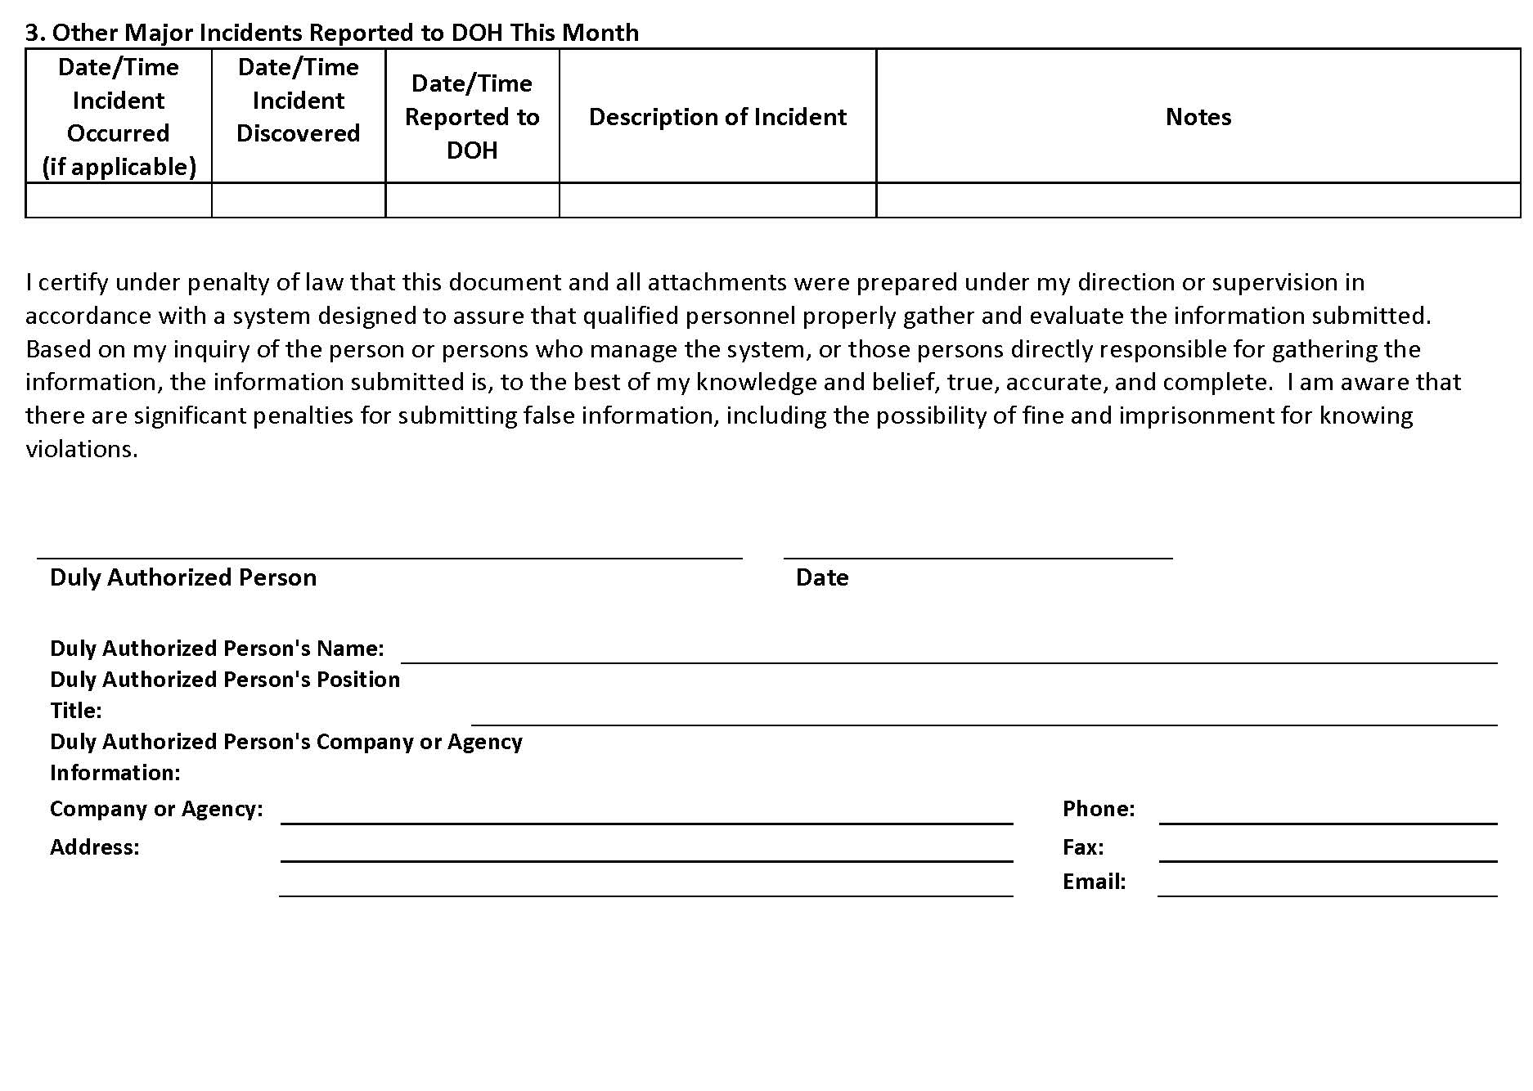

Attachment D4 – CCH Critical Deficiency Report (DRAFT)

☐ Check if Discharge Observed during an Inspection

Date: |  |  |  |  | Inspector/ Engineer:
Project No.: |  |  |  |  |  |  | CCH File No.:
Project Name:
Weather Conditions: |  |  |  |  |  | Inches of Rain in the Past 24 hrs:

Location of Work Activities:

Description of Work Activities:

This report is required when a non-storm water or polluted storm water discharge may have or may have potentially entered a storm drain or receiving state waters, if a discharge (e.g., spill) has occurred, if a polluted discharge is observed leaving the project limits, or if there is evidence of an unreported polluted discharge leaving project limits prior to inspection (such as: silty trail, eroded areas beyond site limits).

1. General Information

Date of Incident: |  |  |  |  | Incident Identified/ Reported by:
*Time of Incident: |  |  |  |  |  | *Duration of Incident:
Source/ Cause of Incident:
Describe the Incident:
*Note if time/ duration is approximate

Is the suspected reason for the discharge that a storm water control is clearly not operating as intended or is in need of maintenance?
☐ BMP needs maintenance | ☐ BMP not operating as intended | ☐ BMP is not a factor

2. Specific Discharge Information

A. Nature of the Discharge: |  |  |  | B. Characteristic of Immediate Area Where Discharge Occurred:
☐ Sediment - Amount: |  |  |  | ☐ Receiving Water(s)
☐ Concrete – Amount: |  |  |  | Name(s):
☐ Oil/ Grease – Amount:
☐ Hazardous Materials |  |  |  | ☐ Storm Drain
Describe: |  |  |  | MS4 Owner:
Amount: |  |  |  | ☐ Soil – Type:
☐ Other |  |  |  | ☐ Asphalt/ Concrete Surface
Describe: |  |  |  | ☐ Other
Amount: |  |  |  | Describe:
C. Location Where Discharge Originated (include location map and photos on attached template): |  |  |  | D. Description of Path of Discharge (include map and/ or photos on attached template):
Where did the polluted discharge ultimately go?
☐ Entered a Drainage System
☐ Directly entered State Waters (discharged directly into stream or other water body)
 |  |  |  | ☐ Other – Describe:
☐ Map or Photos Attached |  |  |  | ☐ Map and/ or Photos Attached.  If the polluted discharge entered a drainage system or receiving water (e.g., stream, ocean), complete section 3.

3. Inlets, Outlets, and Receiving Water Information

List all inlets and corresponding receiving water outfall locations from each drainage system. If discharge went directly to receiving waters, list the point where discharge entered receiving waters. At each point check the characteristics of the water upstream (if applicable), at discharge or outfall location, and downstream of discharge or outfall location (if applicable) and describe (turbidity, color, odor, floating, settled, or suspended solids, foam, oil sheen, and other obvious indicators of storm water pollutants).
If the discharge did not enter a drainage system or receiving water (e.g., stream, ocean), skip this section.

Inlet Location/ Drainage System Owner (if Applicable):
Outfall/ Discharge Location:
Characteristics of Water (turbidity, color, odor, floating, settled, or suspended solids, foam, oil sheen, and other obvious indicators of storm water pollutants):
Upstream of Location (if applicable):
At Outfall/ Discharge Location:
Notes (include information about other inlets entering drainage system prior to outfall, etc.):

4. Action Taken

A. Describe Immediate Measures Taken (include photos on attached template):

☐ Photos Attached

B. Describe Additional Follow-Up Measures Taken (include photos on attached template):

☐ Photos Attached

5. Other Notes/ Comments

I certify that I am the person who performed the inspection documented above and that all information recorded on this form is a true and accurate representation of what was observed at the construction site recorded above.

Inspector Name and Title |  | Signature |  | Date

I certify under penalty of law that this document and all attachments were prepared under my direction or supervision in accordance with a system designed to assure that qualified personnel properly gather and evaluate the information submitted. Based on my inquiry of the person or persons who manage the system, or those persons directly responsible for gathering information, the information submitted is, to the best of my knowledge and belief, true, accurate, and complete. I am aware that there are significant penalties for submitting false information, including the possibility of fine and imprisonment for knowing violations.

Name |  | Date

Duly Authorized Person’s Name:
Duly Authorized Person’s Position Title:
Duly Authorized Person’s Company or Agency Information:
Company or Agency: |  |  |  |  |  | Phone:
Address: |  |  |  |  |  | Fax:
 |  |  |  |  |  | Email:

Location Map

Project No.: |  |  |  | DOH File No.:
Project Name:
Project Location:
Description:

Photos

Photos Taken By:
Project No.: |  |  |  | DOH File No.:
Project Name:

Attachment D5 – Receiving Water State Inspection Report for Individual NPDES Permit Projects

[Delete if not applicable]

Permit NO. HIS , A. General Requirements, Item 6:
Inspect, at a minimum of once per week, the receiving state waters, storm water runoff and control measures and BMPs to detect violations of and conditions which may cause or contribute to a violation of the basic water quality criteria as specified in HAR, Chapter 11-54, Section 11-54-4 (e.g., the Permittee shall look at storm water discharges and receiving state waters for turbidity, color, floating oil and grease, floating debris and scum, materials that will settle, substances that will produce taste in the water or detectable off-flavor in fish, and inspect for items that may be toxic or harmful to human or other life).
The Receiving State Waters Inspection Report for Individual NPDES Permits shall be used to document the weekly inspections of the receiving state waters.

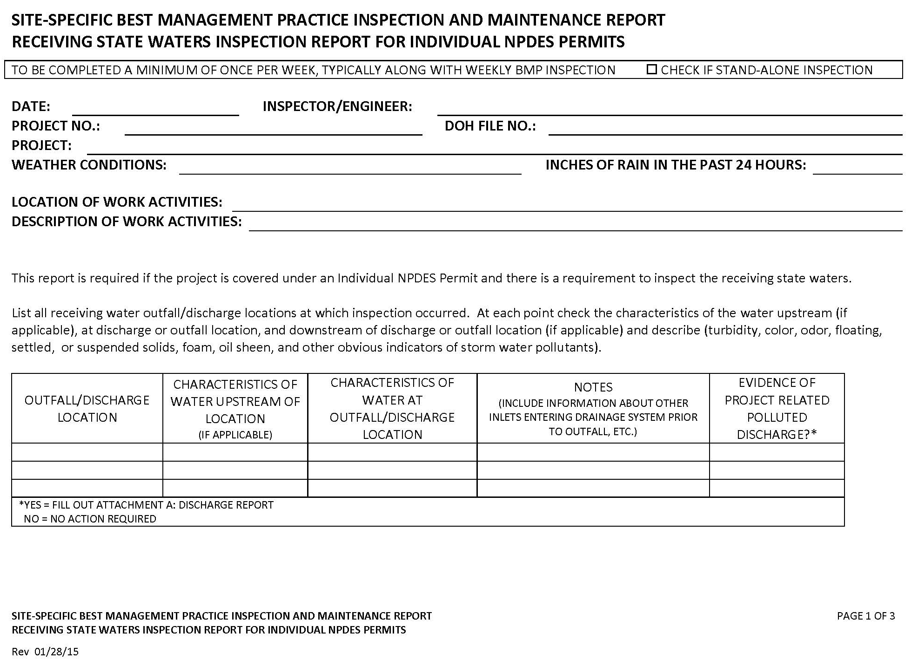
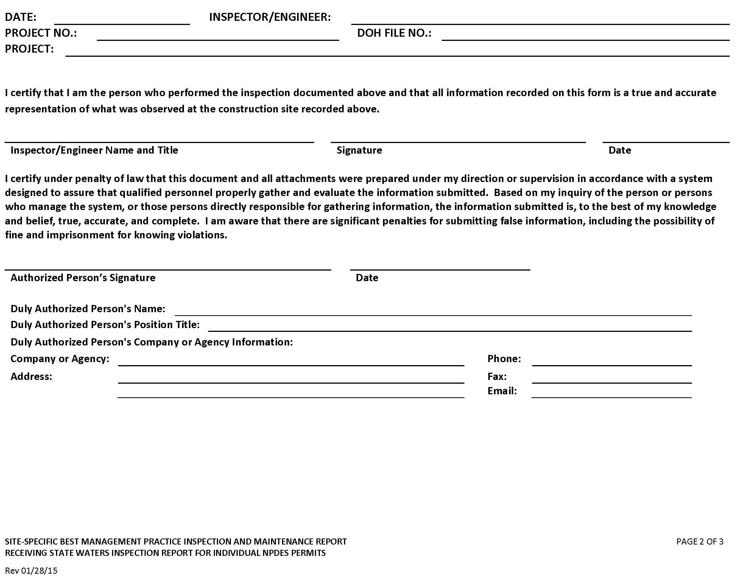
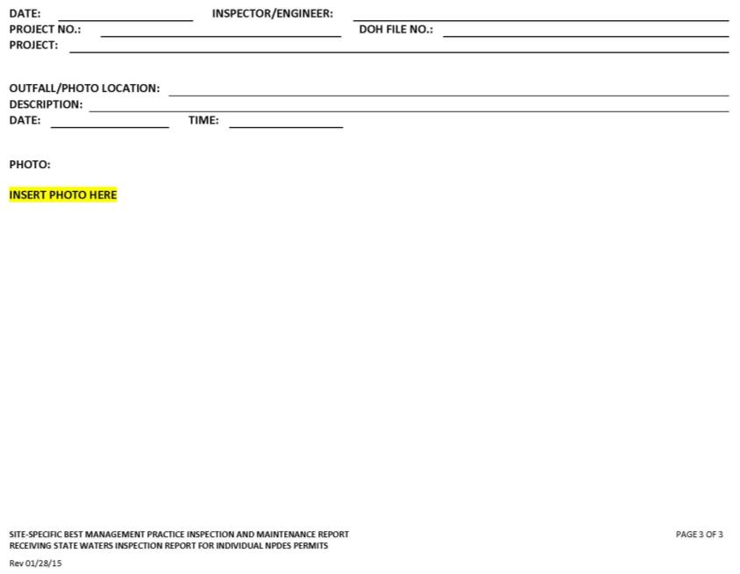

Attachment E: Spill Prevention and Response Procedures (SWPPP Section 7.2.11.1)

Attachment E – Spill Prevention and Response Procedures (SWPPP Section 7.2.11.1)

[Contractor should edit this plan as needed for clarification prior to construction]
This plan describes the response and reporting procedures in the event of a spill at the site in compliance with HAR 11-55 Appendix C Part 7.2.11.1

1. Spill Response Coordination
The Contractor shall appoint a Primary and Secondary Emergency Spill Response Coordinator who will be responsible for the reporting of spills, coordinating contractor personnel for spill cleanup, subsequent site investigations, and associated reports. In the event of a spill, the Emergency Spill Response Coordinator will be responsible for determining the extent of the containment/isolation area and cleanup methods. Include Names, positions, and emergency contact information for the spill response coordinator.
The Contractor shall make contact with a Spill Cleanup Emergency Response Contractor prior to start of construction to provide sufficient information for the spill contractor to be prepared should they receive a call in the event of an emergency. In the case of a wastewater spill to private facilities or a fuel spill, the contractor is responsible to contract with cleanup providers and to be onsite and respond to spill within 4 hours. The contractors must provide a letter from company indicating that they will provide emergency services for this project and contractor. A letter shall be kept with this SWPPP attachment.

Contact information for spill response and notifications are below and should be completed prior to the start of construction.

Contact Information:
Area | Name | Work/ Daytime Phone |  | Other Phone/ Contact
Contractor Emergency Spill Response Coordinators
Primary Contact |  | - |  | -
Secondary Contact |  | - |  | -
City and County of Honolulu Project Contacts:
Construction Branch Chief |  | - |  | -
Project Engineer |  | - |  | -
Supervising Inspector |  | - |  | -
DFM Storm Water Quality Branch |  | 768-3300
Other: |  | - |  | -
Local Emergency and Utility Contacts:
Fire Department | Honolulu Fire Department | 911
Police Department | Honolulu Police Department | 911
Local Emergency Planning Committee (LEPC) | Oahu LEPC | 723-8960
Coast Guard | Coast Guard Operations Center, Honolulu | 522-8246 |  | 808-247-2191
Hawaii Department of Transportation | HDOT Tunnels Emergency Contact Number | NA |  | 808-485-6200
Water | Board of Water Supply | 748-5000 |  | 748-5000
Sewer – City | Dept of Environmental Services, Collection System Maintenance Division | 768 7272 |  | (808) 768 7272, call 24/7
Gas | Hawaii Gas | 526-0066 |  | 526-0066
Electric | Hawaiian Electric | 1-855-304-1212
State Contacts:
Hawaii Department of Health | Hazard Evaluation and Emergency Response (HEER) Office | 808-586-4249 |  | Hawaii State Hospital 808-247-2191 (after business hours)
Hawaii Department of Health | Clean Water Branch (CWB) | 808-586-4309 |  | Hawaii State Hospital 808-247-2191 (after business hours) and email cleanwaterbranch@doh.hawaii.gov
Federal Contacts:
Spill Response Hotline | National Response Center (NRC), U.S. Coast Guard, Washington D.C. | 800-424-8802
United States Environmental Protection | Region IX – Honolulu Office | 808-541-2701
Cleanup Contractors:
Sewer – Privately Owned¹ |  | - | -
Fuel or Oil Spill² |  | - | -
Other: |  | - | -

¹Contractor is responsible to contract with a private provider and to be onsite and respond to spill within 4 hours. Provide a letter from company indicating that they will provide emergency services for this project and contractor. A letter shall be kept with this SWPPP attachment.

2. Response Guidelines:
The following is a description of the immediate actions taken by onsite personnel in the event of a spill.
WHAT TO DO:
1st Responder (All Staff) | Control | - Stop the source of the spill and keep it from spreading.  - Protect drains with drain covers or dikes.  - Extinguish all ignition sources.  - Isolate the spill area to prevent personnel or vehicles from inadvertently entering the area.
 | Call | Immediately for All Spills  Emergency Spill Response Coordinators: -
 | Standby | Remain available to assist with cleanup as directed by emergency spill response coordinator
Contractor Spill Response Coordinator: | Call | CCH Project Engineer: -  CCH Supervising Inspector: -  Emergency Cleanup Contractors: -
 | Call | Immediately if Spill is greater than Reportable Quantities  DOH Clean Water Branch: 808-586-4309  and email: cleanwaterbranch@doh.hawaii.gov  NRC: 1-800-424-8802 or online at: http://www.nrc.uscg.mil/report.html  DOH HEER: 24 hr. 808-586-4249 (or 808-247-2191 after hours)
 | Direct Cleanup | Unless directed otherwise by DOH HEER:  Assemble and instruct team in clean up as follows:  - Don protective gloves, safety goggles, etc.  - Using spill kit materials, place enough sorbent over the spill so that all of the spilled material is absorbed.  - If material reached bare soil, dig up all stained soil.  - Containerize the solid absorbent materials soil in accordance with normal waste handling procedures for hazardous and non-hazardous waste as appropriate for the material spilled.  - Initiate procedures to obtain contractor assistance.²
 | Emergency Situation | If the situation becomes uncontrollable, or the substance is unknown and beyond contractor capabilities:  - Call 911  - Evacuate if: Toxic fumes /Any explosion potential /Fire  - Commit resources to direct cleanup activities as needed.
CCH Project Contact: | Call | CCH Construction Branch Chief: -  If discharge goes into the CCH MS4:  CCH Storm Water Quality Branch:768-3300
¹Reportable quantities are discussed in Section 4 of this Spill Response Plan
²The contractors is required to have a cleanup contractor prior to the start of construction. In the event of a spill, while waiting, contractor shall attempt to contain spill. If wastewater enters into City storm drain system, the contractor is responsible to remove wastewater from storm drain system. If fuel or oil enters into City storm drain system or waters of the US, the contractor is responsible to remove fuel and oil under the direction of the State HEER office.

3. Spill Response Equipment
Contents of the spill kits shall be determined by the Contractor based on the anticipated type and quantity of hazardous material to be stored/ used on-site. The kit should contain at minimum:
- 55 gallon drum with lid
- Absorbent pads (50)
- Absorbent socks (12)
- Absorbent pillows (5)
- 1 pair goggles or faceshield
- 1 pair elbow length gloves
- 1 disposable apron
- Disposable bags with ties (3)
- Include additional materials such as Absorbent Skimmers or Booms for work adjacent or over State Waters as needed.
- Include additional materials as necessary to secure the spill area.

4. Notification Requirements (5.3.4)
Part 5.3.4 of the HAR 11-55 Appendix C requires:
“The permittee is prohibited from discharging toxic or hazardous substances from a spill or other release, consistent with section 5.3.1.5. Where a leak, spill, or other release containing a hazardous substance or oil in an amount equal to or in excess of a reportable quantity established under either 40 CFR Part 110, 40 CFR Part 117, or 40 CFR Part 302 occurs during a 24-hour period, the permittee shall notify the National Response Center (NRC) at (800) 424-8802 , the Clean Water Branch during regular business hours at 586-4309, and the Hawaii State Hospital Operator at 247-2191 and the Clean Water Branch via email at cleanwaterbranch@doh.hawaii.gov during non-business hours as soon as the permittee has knowledge of the discharge. The permittee shall also, within 7 calendar days of knowledge of the release, provide a description of the release, the circumstances leading to the release, and the date of the release. State and local requirements may necessitate additional reporting of spills or discharges to local emergency response, public health, or drinking water supply agencies.”
Reportable quantities (RQs) in 40 CFR 110, 40 CFR 117 and 40 CFR 302 can be found using the URLs provided below. It is the contractor’s responsibility to maintain an inventory of chemicals on-site and to know what the reportable quantities are for those chemicals.

40 CFR Part 112.3: OIL POLLUTION PREVENTION
http://www.ecfr.gov/cgi-bin/text-idx?SID=103d998618eb1d9be38283cbafb3b165&mc=true&node=se40.22.112_16&rgn=div8

40 CFR Part 117.3: DETERMINATION OF REPORTABLE QUANTITIES FOR HAZARDOUS SUBSTANCES
http://www.ecfr.gov/cgi-bin/text-idx?SID=95d284c127fa61a656760be5de4cbd55&mc=true&node=se40.22.117_13&rgn=div8
40 CFR Part 302: DESIGNATION, REPORTABLE QUANTITIES, AND NOTIFICATION
http://www.ecfr.gov/cgi-bin/text-idx?SID=520fa9b6a9e75f1e186d59880ee4cf37&mc=true&node=se40.28.302_14&rgn=div8
Below is a reporting summary. There may be additional reporting requirements for other permits or agreements that the project is required to comply with. RQs for oil vary between agencies and are listed below the table.

Reporting Requirements
Report to: | When | How | All | Greater than RQ | To Surface Water (any sheen), storm drain, or sanitary sewer
CCH Project Contacts | ASAP | phone | X | X | X
NRC | ASAP | phone |  | X¹ | X
DOH HEER | ASAP | phone |  | X² | X
 | 30 days | Written report
DOH CWB | ASAP | phone |  | X³ | X
 | 7 days | Written Report
RQ for Oil:
¹NRC: Any quantity of discharged oil that 1) violates state water quality standards, 2) Causes a sheen on the water’s surface or adjoining shore lines, 3) leaves sludge or emulsion beneath the surface.
²HEER: 1) any amount of oil which when released into the environment causes a sheen to appear on surface water or any navigable water of the state; 2) any free product that appears on ground water; 3) Any amount of oil released to the environment greater than 25 gallons; and 4) Any amount of oil released to the environment which is less than 25 gallons but which is not contained and remedied within 72 hours.
³40 CFR 112.3: 1) More than 1,000 US gallons of oil in a single discharge or 2) more than 42 US gallons of oil in each of two discharges as described in 112.1

A Written Report template from the DOH HEER is provided below.
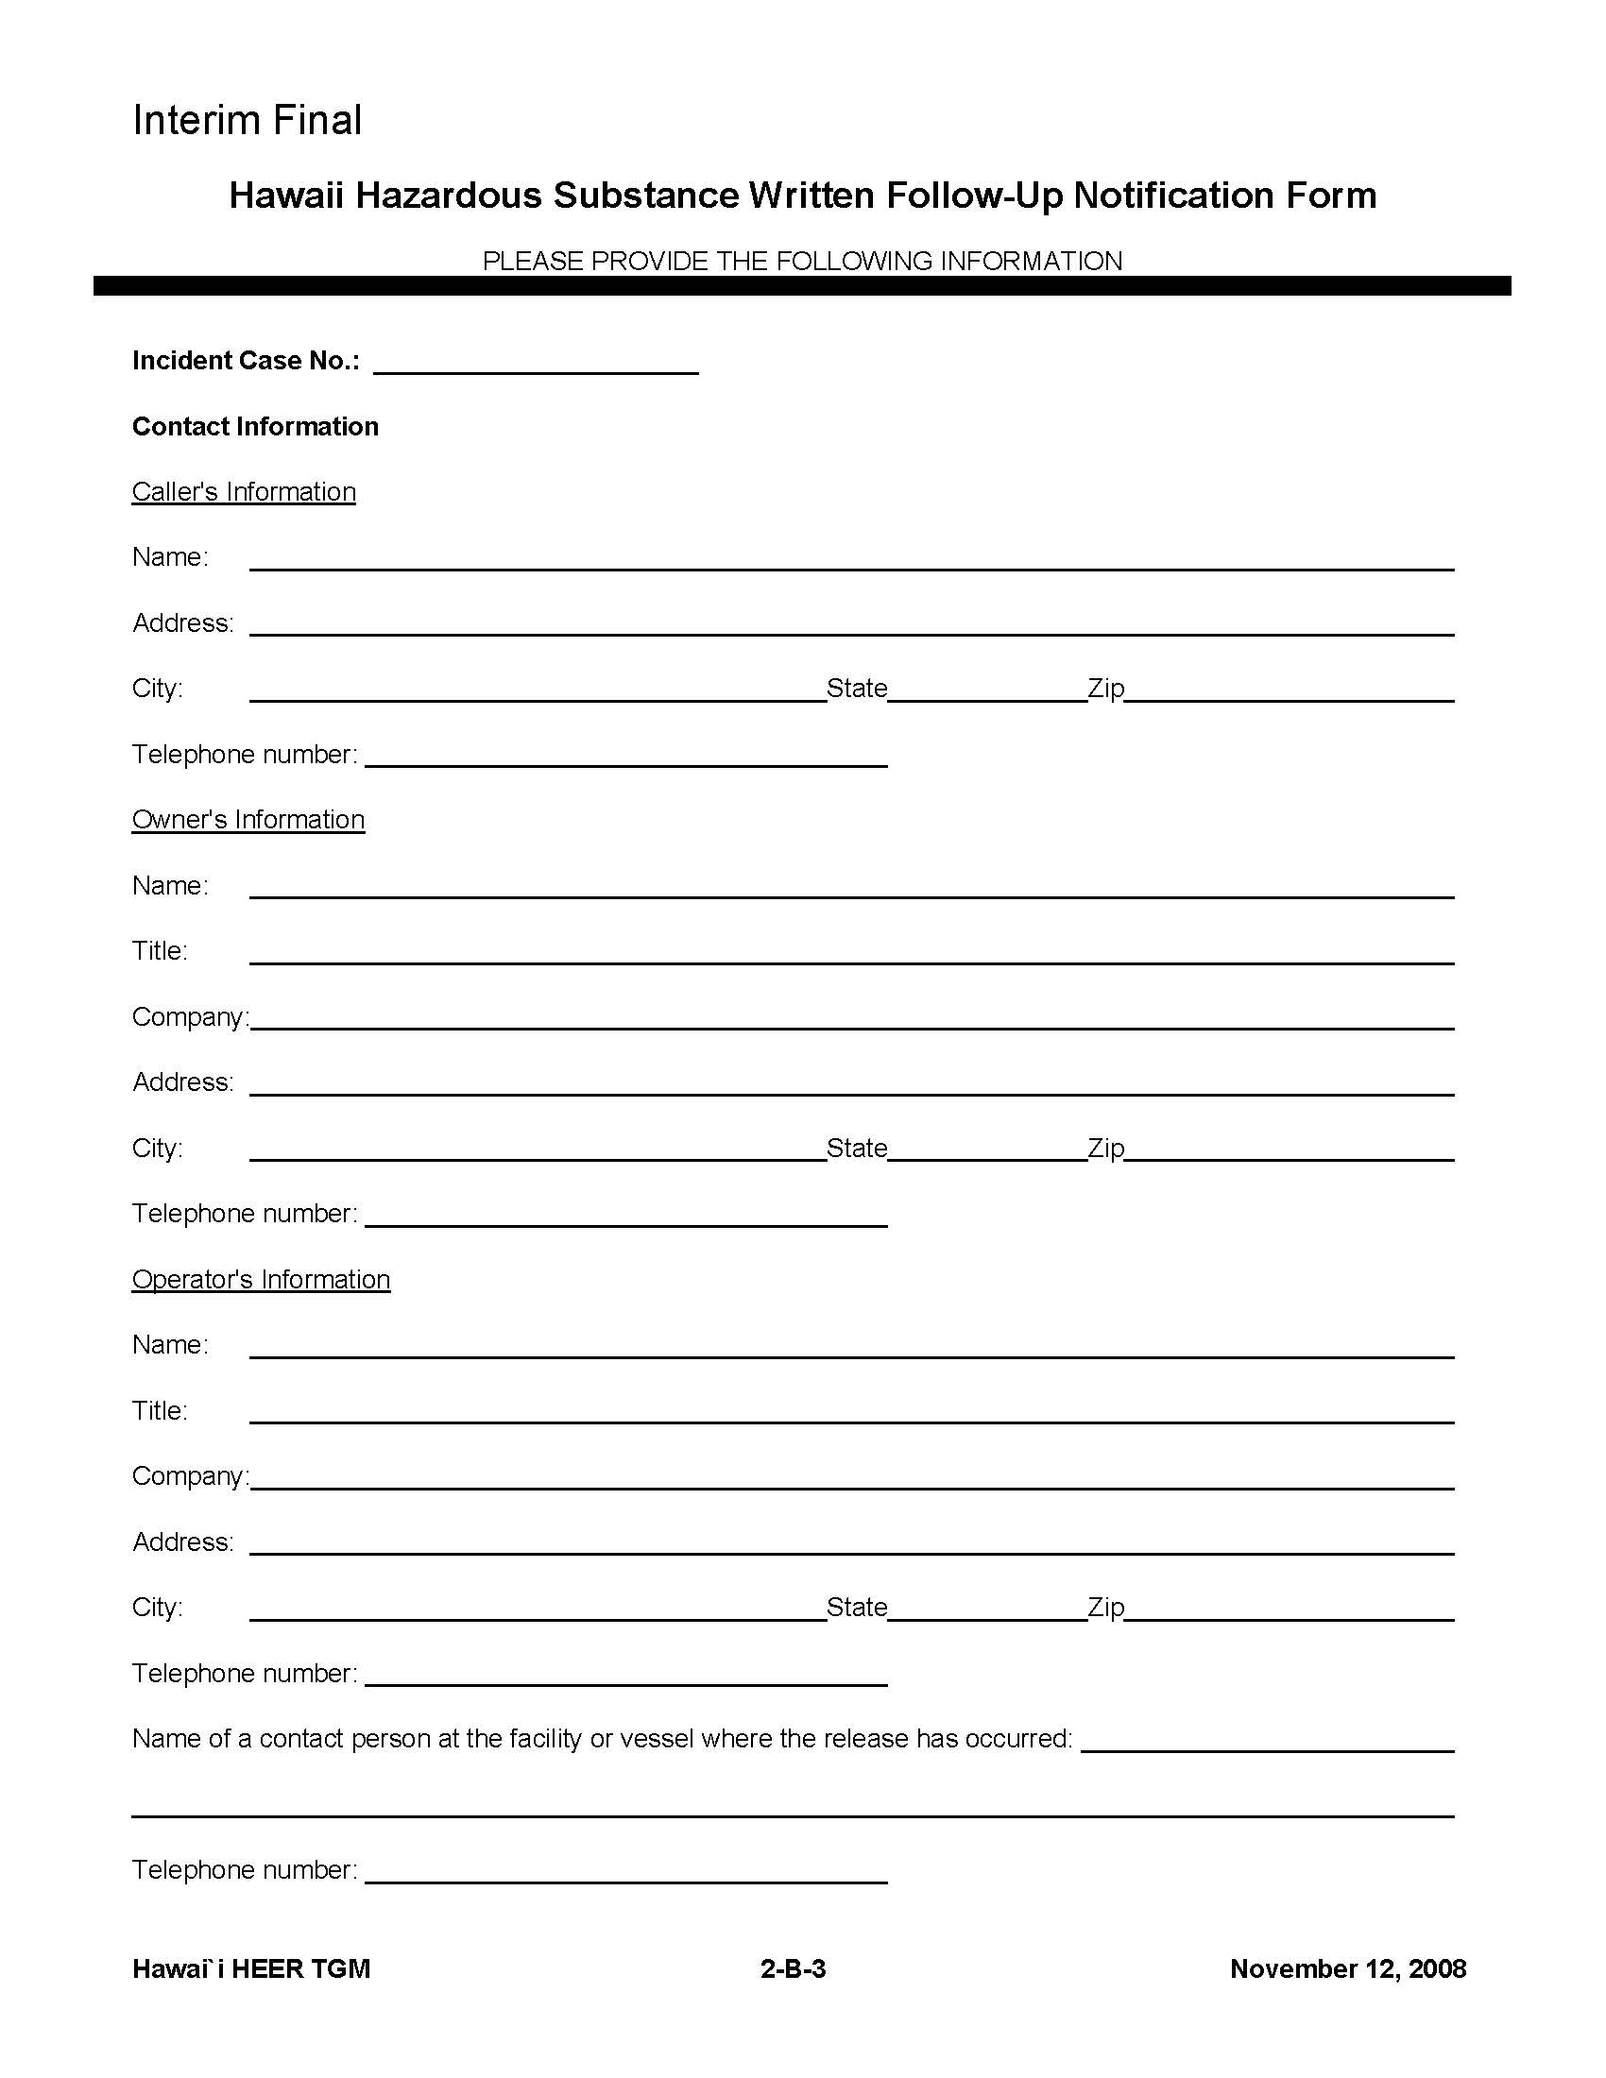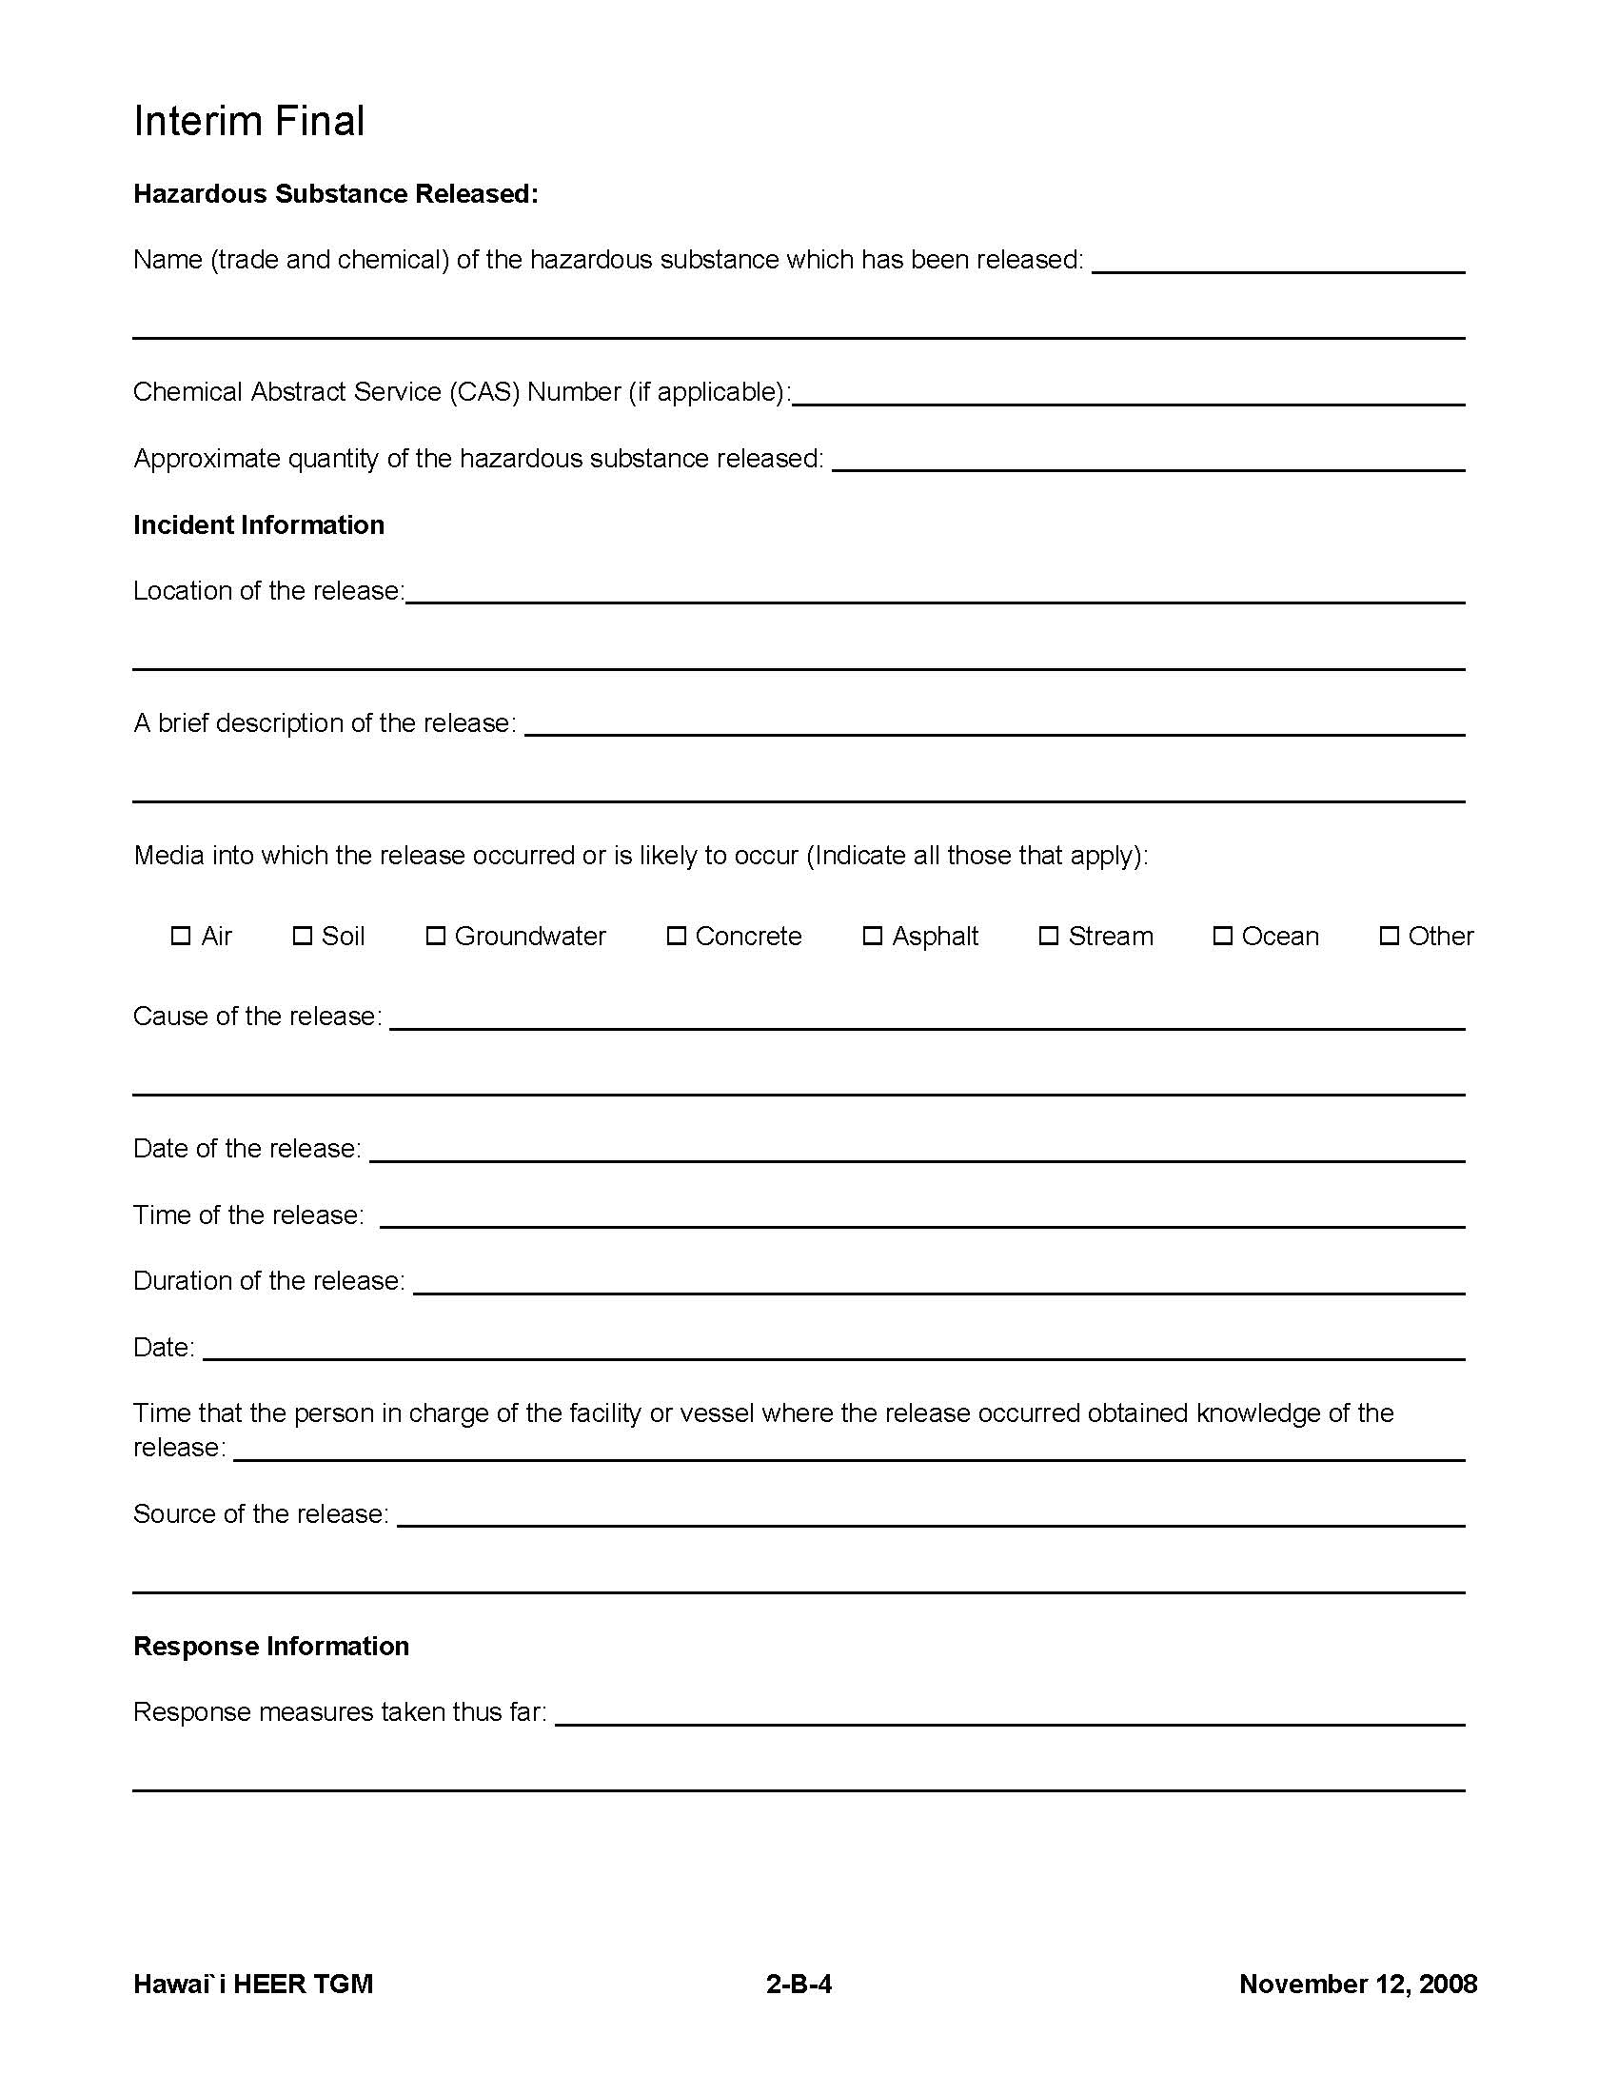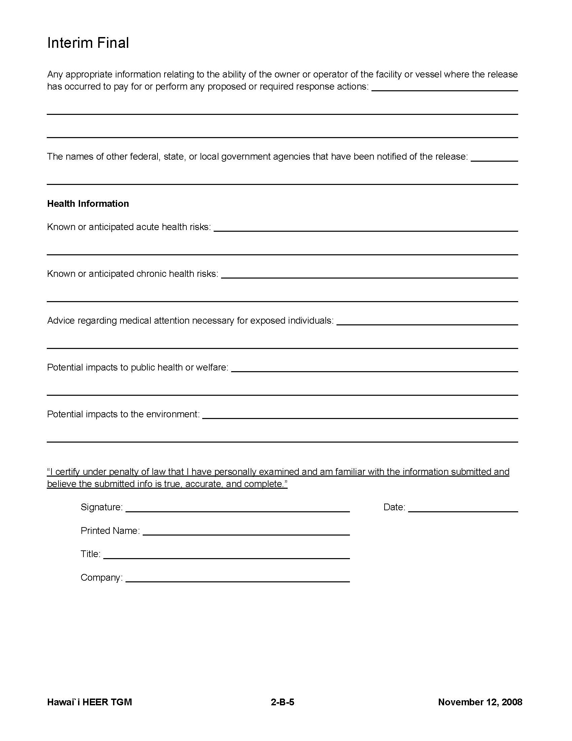

Attachment F: Waste Management Procedures (SWPPP Section 7.2.11.2)

Attachment F1 – Solid Waste Disclosure Forms and Receipts

The Contractor shall submit the DOH “Solid Waste Disclosure Form for Construction Sites” to the Engineer within 30 calendar days of contract execution. The signed solid waste disclosure form shall be included here. Include the solid wastes produced by your Sub-contractors, all solid waste should be accounted for. The form can be downloaded at: http://health.hawaii.gov/shwb/files/2013/06/swdiscformnov2008.pdf

Provide a copy of all the disposal receipts from the facility permitted by the Department of Health to receive solid waste to the Engineer monthly, this should also include documentation from any intermediary facility where solid waste is handled or processed, or as directed by the Engineer.

Attachment F2 – Litter Management Plan

[Contractor shall edit once contract is awarded]
- Construction site preparations.
Before the start of construction activities, during the mobilization process, proper litter waste receptacles will be located at the construction site. Litter receptacles will be placed within the boundaries of the project right-of-way or within a project related vehicle on-site. Construction debris receptacles that accept mixed reuse may also act as litter control receptacles.
- Daily Construction Site Litter Prevention Activities.
- Pre-Construction activities litter prevention and control activities.
- At the start of each work day, the active work areas of the construction site(s) will be inspected for litter debris.
- Litter debris found will be collected and properly sorted into the proper debris receptacle.
- Litter will be collected whether or not it was sourced from the job site and construction related activities.
- After collection, litter will be disposed of in appropriate waste containers and all practices outlined in the Waste Management Plan will be followed.
- Waste containers will be inspected regularly to prevent overfilling.

- Post-Construction Site Litter Prevention Activities
- At the end of each work day, the active work areas of the construction site(s) will be inspected for litter debris.
- Litter debris found will be collected a property sorted into the proper debris receptacle.
- Litter will be collected whether or not it was sourced from the job site and construction related activities.
- After collection, litter will be disposed of in appropriate waste containers and all practices outlined in the Waste Management Plan will be followed.
- Waste containers will be inspected regularly to prevent overfilling.

- BMPs and Litter Control
- Construction Site BMPs will be inspected for litter debris when conducted weekly BMP inspection or after a significant rain event as litter debris may reduce the performance of BMPs.

Attachment G: Contingency Plan

Attachment G – Contingency Plan

[Contractor shall edit as applicable]
Provide a contingency plan that will be implemented to prevent or respond to a polluted discharge resulting from a severe storm or natural disaster. Include how the weather will be monitored, site will be secured, and who to notify at CCH.

SEVERE STORM CONTINGENCY PLAN

The following plan will be implemented by the General Contractor to prevent/ respond to polluted discharges resulting from a severe storm or natural disaster. It is the General Contractor’s responsibility to abide by the following plan as well as any other binding plan, agreement, regulation, rule, law, or ordinance applicable.
All contactors associated with the following construction project: [Project Name]:

will follow this plan when a severe storm is either forecast or anticipated or as directed by the Engineer.
General Contractors shall:
- Regularly monitor local weather reports for forecasted and/or anticipated severe storm events, advisories, watches, warnings or alerts. The Contractor shall inspect and document the condition of all erosion control measures on that day prior, during, and within 24 hours after the event. The Contractor shall prepare for forecasted and/or anticipated severe weather events to minimize the potential for polluted discharges.
- Secure the construction site. Securing the site shall include at a minimum:
- Removing or securing equipment, machinery, construction materials, and portable toilets. If portable toilets are to remain on-site, they shall be pumped the day prior to the event.
- Cleaning up all construction debris.
- Stopping scheduled material deliveries.
- Locating and turning off jobsite utilities, including electricity, water, and gas.
- Implementing all Best Management Practices detailed in the SWPPP. This includes BMPs for materials management, spill prevention, and erosion and sediment control. To protect human health, the Engineer will use their discretion as to whether to remove BMPs which may impede flow into inlets causing ponding on the roadway. These changes shall be noted on the SWPPP.
- Work crews shall finalize securing the project site, and evacuate until the severe weather condition has passed.
- Upon return to the Site, all BMPs shall be inspected, repaired and/or re-installed as needed. If repair or reinstallation of removed BMPs is necessary, it shall be initiated within 24 hours of the inspection. Note the changes on the SWPPP. To facilitate repair or replacement, the Contractor shall be required to store surplus material on the project site if the site is located where replacement materials will not be readily available.
- When there has been a discharge which violates Hawaii Water Pollution rules and regulations OR there is an imminent threat of a discharge which violates Hawaii Water Pollution rules and regulations and/or endangers human and/or environmental health, the Engineer shall, at a minimum, execute the following steps:
- Assess whether construction needs to stop or if additional BMPs are needed to stop or prevent a violation.
- Direct the Contractor to take all reasonable measures to protect human health and the environment.
- Notify responsible parties listed below and immediately notify the DOH of the incident. The notification shall also include the identity of the pollutant sources and the implemented control or mitigation measures.
Responsible Parties | Name | Emergency Contact Number
Owner Contact
Owner Contact
Owner Contact
Department of Health Clean Water Branch (During regular working hours) |  | 808-586-4309
Hawaii State Hospital Operator (After hours) |  | 808-247-2191

- Document corrective actions, take photographs of discharge and receiving waters.
- Evaluate the effectiveness of the construction BMPs in the SWPPP. Consider strengthening existing BMPs or adding additional BMPs.

Attachment H: Post-Construction Storm Water Quality Report

[Attach SWQC or SWQR as required by the City’s Rules Relating to Water Quality: http://www.honoluludpp.org/ApplicationsForms/StormWaterQuality.aspx]
Attachment H – Post-Construction Storm Water Quality Report

Attachment I: Emergency Related Projects, Buffer Documentation, Documentation of Compliance with UIC Requirements, & Other Information as Requested by the Director

Attachment I - Emergency Related Projects, Buffer Documentation, Documentation of Compliance with UIC Requirements, & Other Information as Requested by the Director

Add additional rows or attach sheets with additional TMKs.
NPDES General Construction Permit: required when project discharges to an impaired water and when > 0.25 inch rainfall event occurs; or NPDES Individual Permit: check your specific permit but typically required when >0.5 inch rainfall event occurs.

